- Purpose
  - The purpose of this document is to describe the procedure for final assembly on the Genesys Mid-Sized Scrubber, Orbital Version with Lithium Batteries.
- Scope
  - This SOP applies to all equipment assembly team members. The process applies to all machine ID’s:
- Responsibilities
  - The operations manager/supervisor is responsible for enforcing this SOP.
- Materials
  - The proper materials needed for this process are listed on the machine work order.
- Definitions

- Procedure
  - Place a frame and solution tank assembly (Roller) onto a build cart.
  - Place a foam battery spacer (E28785) into place. Position it so that it is about 1” below tank edge.
  - Install a lithium battery (E28495 for a 200AH battery / E28494 for a 150AH Battery) into the compartment in the orientation shown.
  - Place a 2nd foam spacer (E28785) in front of the battery.

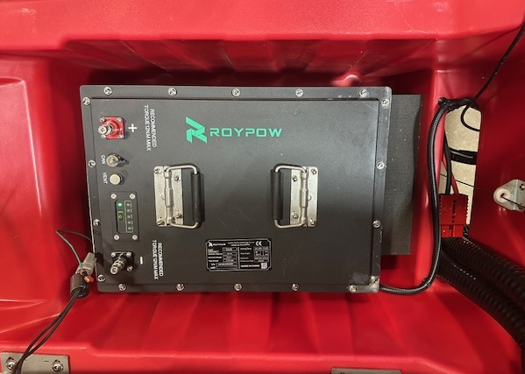
Foam Spacer
Deck Side
Operator Side

  - Attach the end of the squeegee lift cable to the pivot. Thread a hex nut (E29565) up towards the top of the stud. Place a flat washer (E28617) over the threaded end and feed the stud through the hole on the squeegee mounting bracket. Then place a spherical washer (E28717) over the end of the stud and attach everything using another flat washer (E28617) and nut (E29565). Thread the nut up enough so that the assembly can still pivot properly.
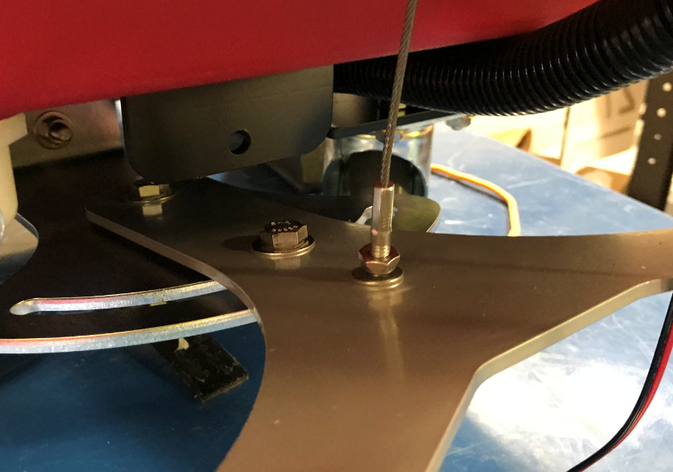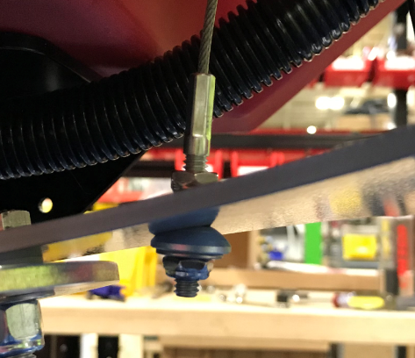

  - Take an Inner Electrical Panel (E28963). Add red loctite onto the standoff threads.

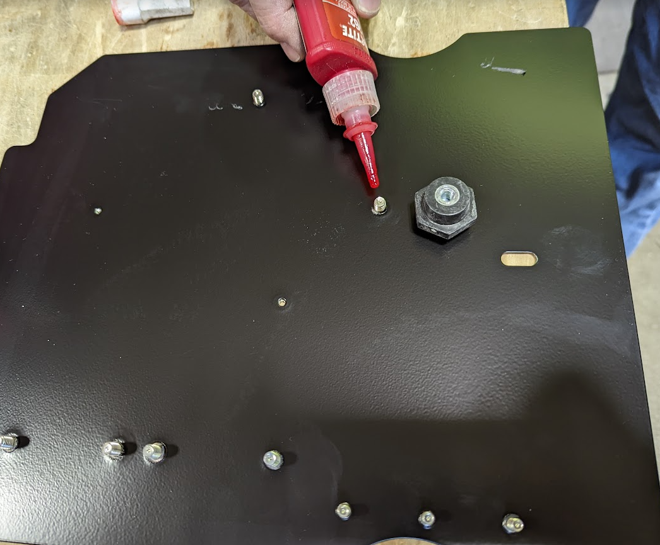
  - Attach an electrical standoff (E28950) to each stud and snug it in place. Be careful to not overtighten. Put some red Loctite onto a set screw (E29447) and thread it into the standoff. Repeat for the other standoff.

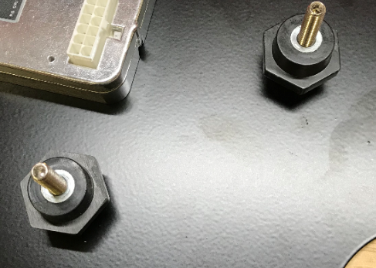

  - Mount the inner panel assembly to the solution tank using 2 screws (E28648) and 2 toothed washers (E29446). It will only fit in one direction as shown.
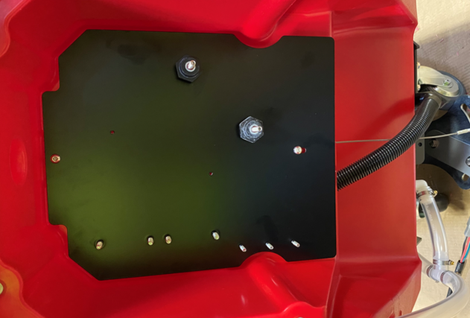

  - Pull the main wire harness back out of the back of the machine, then feed the portion of the main wiring harness that goes to the vac motor into the battery compartment as shown.

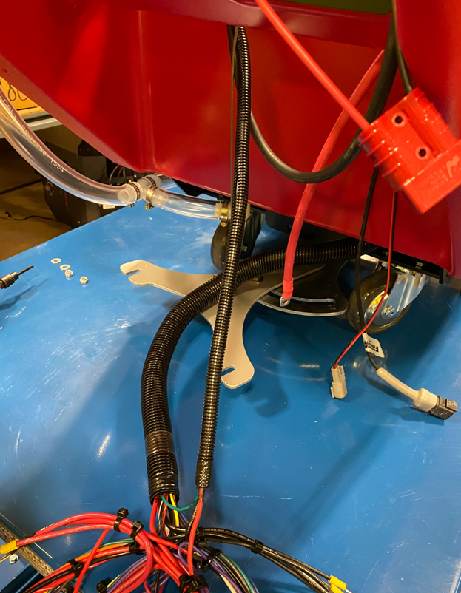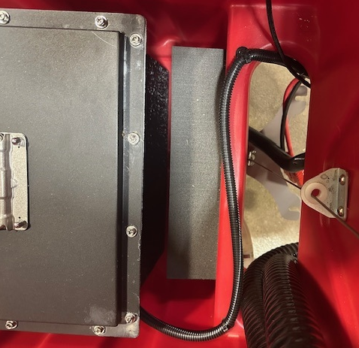

  - Take a set of battery cables (E28497) and separate the two halves. Note that one half has an inline 100 amp fuse.

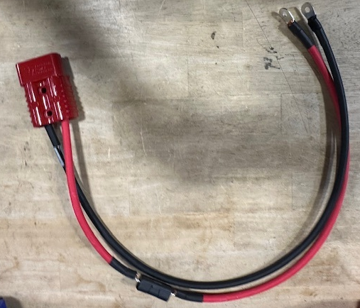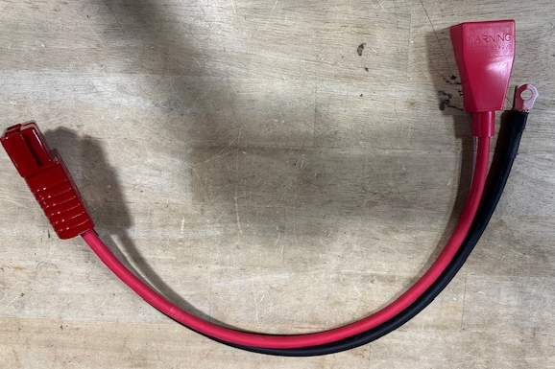

  - Take the cable set with the fuse and place the positive and negative wires onto the standoffs in the electrical panel. Place them onto the locations shown. The Anderson end of the cable should remain in the battery compartment.

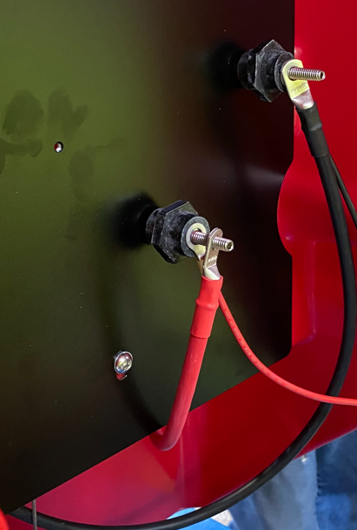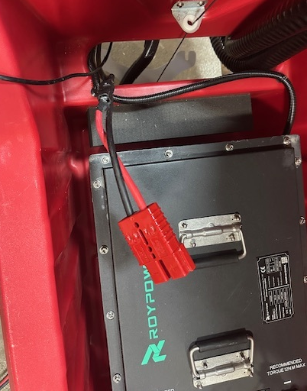

  - Attach the + and – terminals from the main harness to the appropriate standoffs on the panel. Fan the terminals out so that they tighten up properly. Unless there are options on the machine, the nuts on the studs can be tightened. Use a nut (E28853) and a washer (E28617) on each one. Use a torque wrench to tighten to 8 ft-lbs. Tug on the wires to ensure they do not move. When using the torque wrench, only hold on the handle as shown to get an accurate reading.

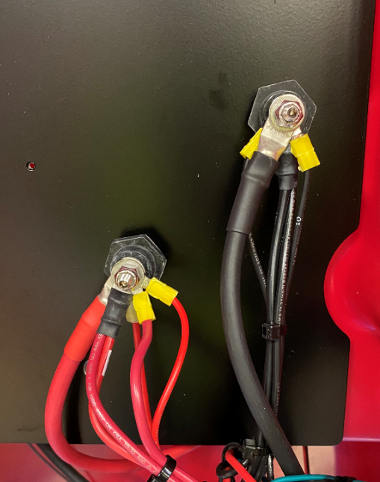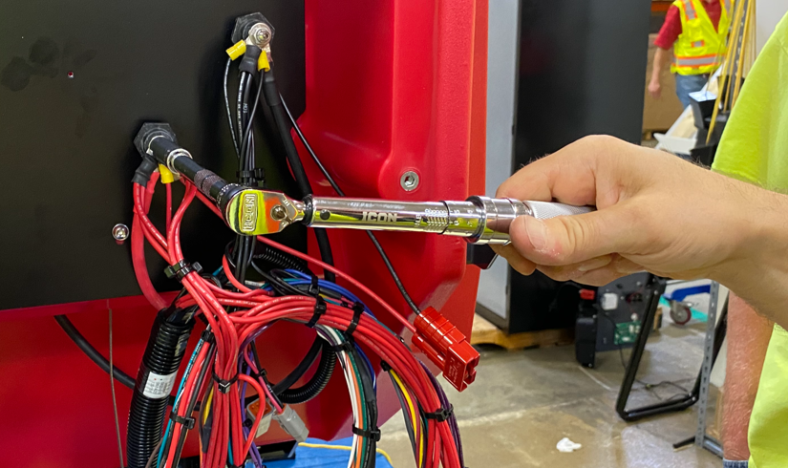

  - Mount the relays from the main harness to the appropriate studs on the panel with hex nuts (E29366). Ensure they are tight. Locate the smaller relay on top.

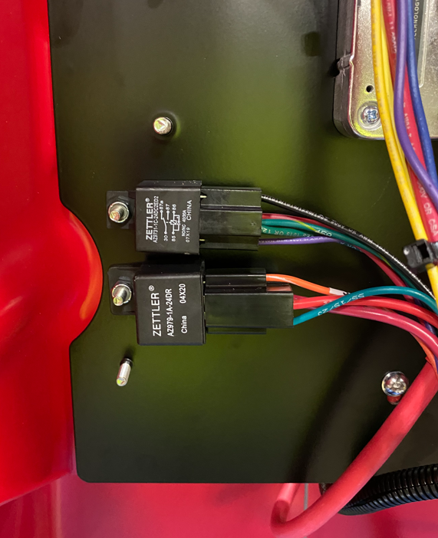

  - Connect the appropriate connectors on the main harness to a Contactor (E28924). The hardware is already on the contactor. For an orbital machine, there will only be 1 contactor. The order of the wires is not critical but to be consistent, place the yellow on top as shown. Use a ratchet/nut driver to ensure the nuts are fully tightened. Mount the contactor to the panel using 2 nuts (E28618). Pull on the wires to make sure they don’t move.
Wire Numbers
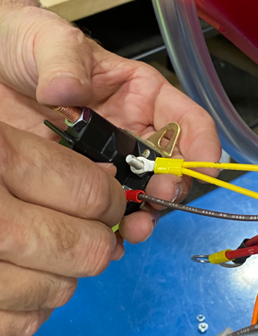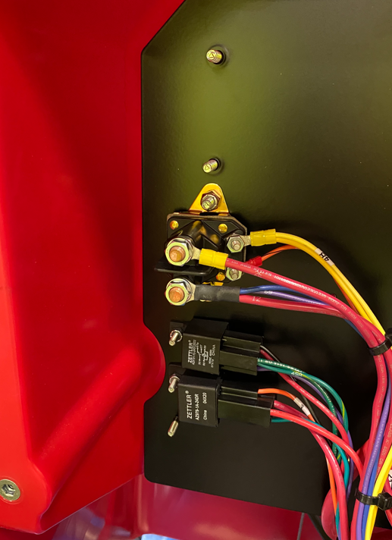
12/65/36
2E
4 & 4B
33
  - Connect the appropriate connectors on the main harness to the I-Drive (E28949). There are 4 single wires, a 2 pin connector, and a 14 pin connector. Note the labels and locations below.
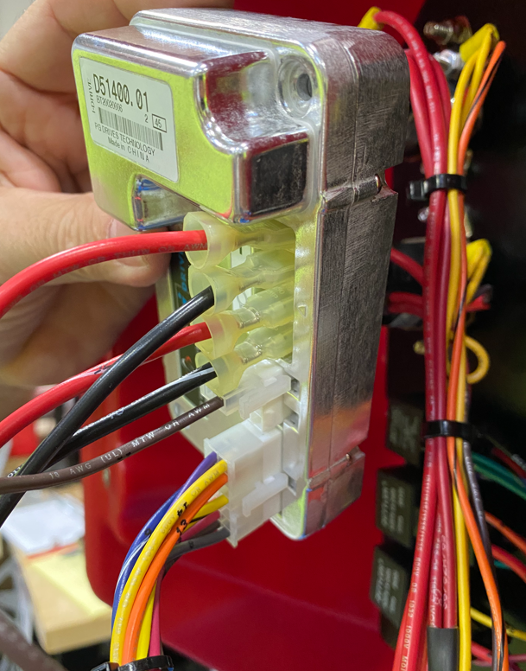
2 pin connector with single brown wire
14 pin connector
42
10D
52
70
  - Attach the I-Drive to the panel using 2 Pan Head Screws (E29382).

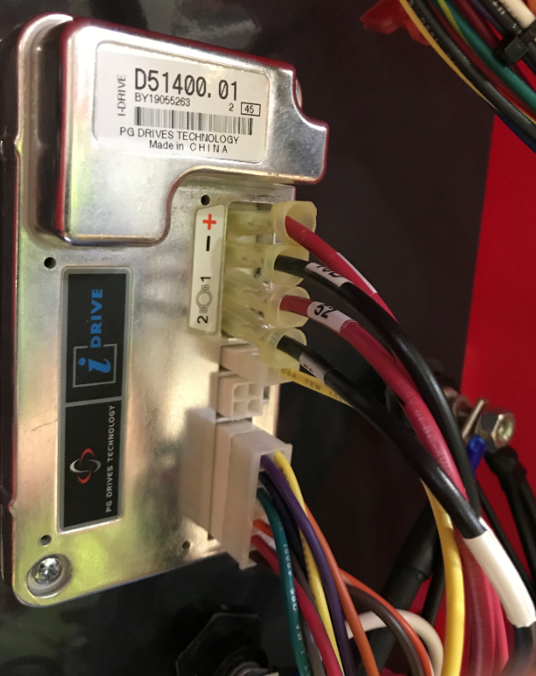

  - Feed the wires for the handle console/bail through the holes and into the upper cavity.
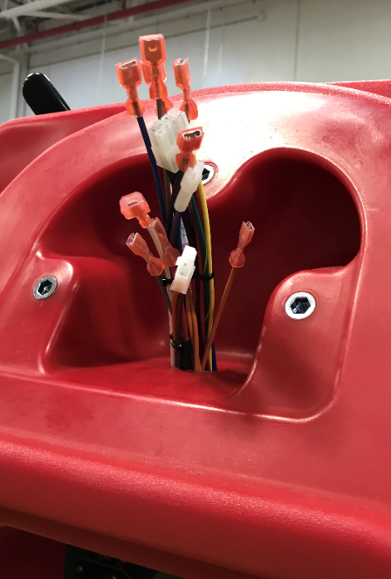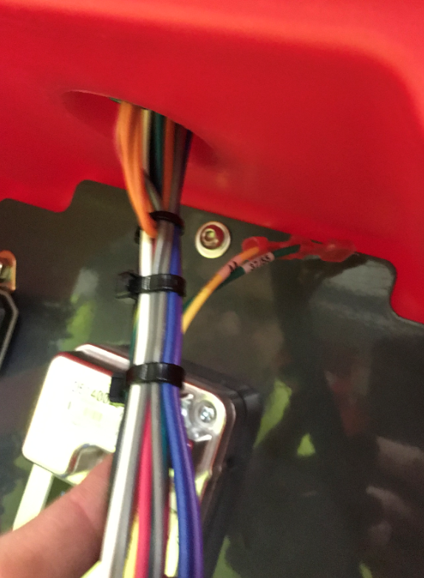
These 2 wires always stay in the lower compartment
  - Take a bail assembly (See the appropriate SOP for assembly instructions) and connect the microswitches to the appropriate wires from the main harness up in the handle attach area of the tank. The photo shows the correct sequence. Wire numbers are noted in the photo.
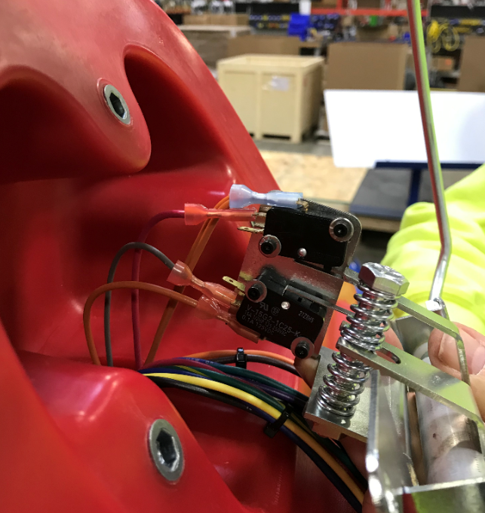
63&63A
62
8
63A
  - Attach the bail assembly to the solution tank using 2 bolts (E81089) and 2 washers (E81062). Ensure the wires are coming out of the appropriate side of the bracket as shown.

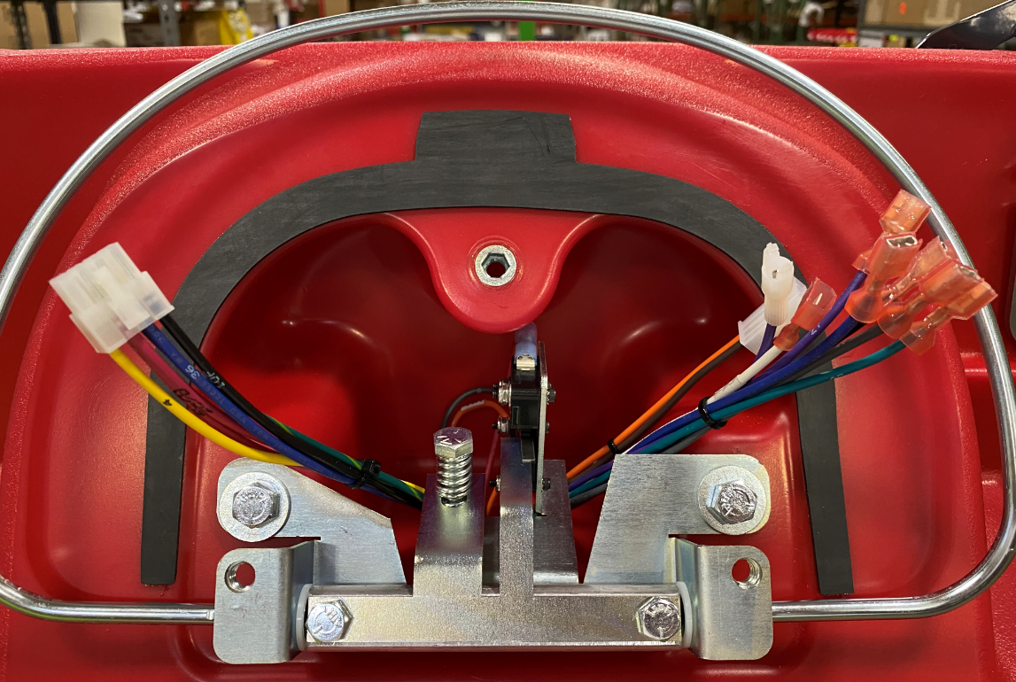

  - Get a handle assembly. See the appropriate SOP for assembly instructions. Connect the potentiometer from the handle to the appropriate terminal on the main harness.
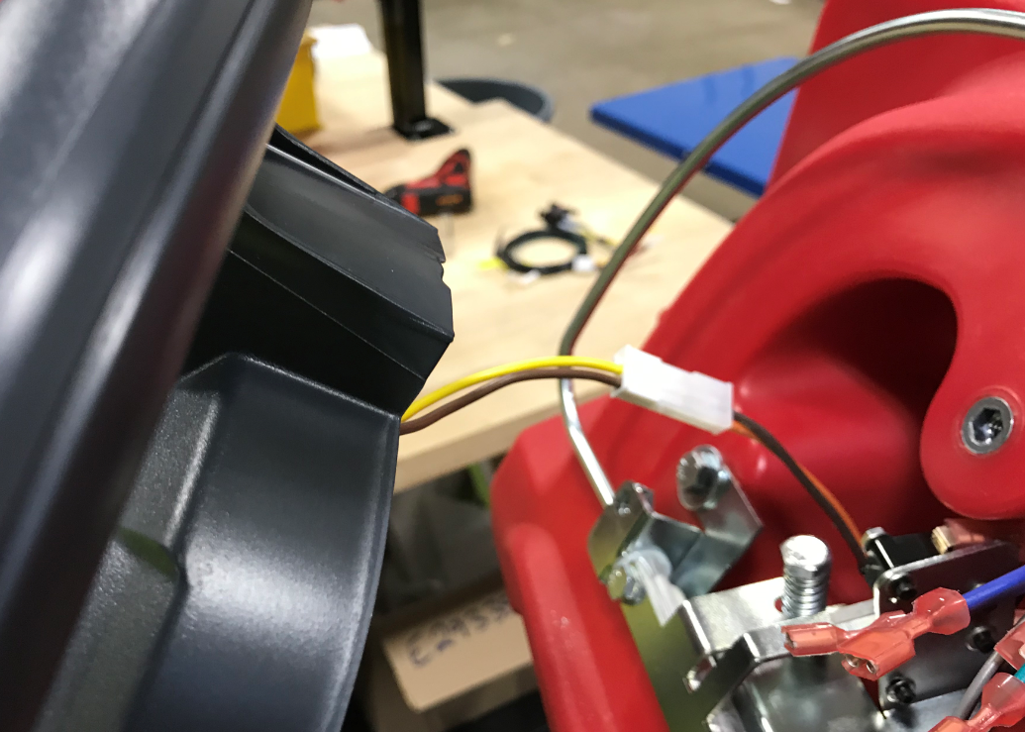

  - Fasten the plastic handle to the tank using 3 bolts (E81089) and 3 washers (E81062). Use Blue Loctite on the bolts. Make sure to not pinch any of the wires on the harness.

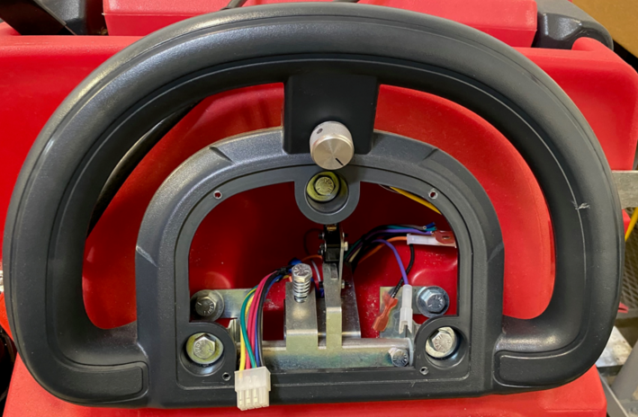

  - Take an appropriate console panel for lithium (See SOP for Assembly Instructions).
  - Connect the 8-pin connector from the main harness to a jumper assembly (E28498).

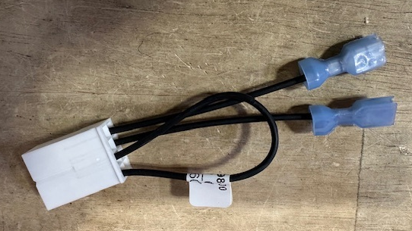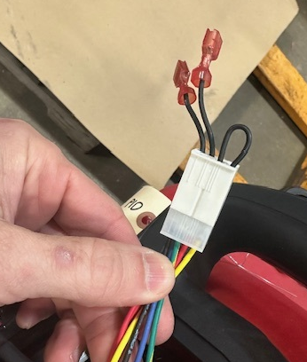

  - Connect the two wires from the jumper to the two terminals on the back of the hour meter on the console. It does not matter which wire goes to which terminal.

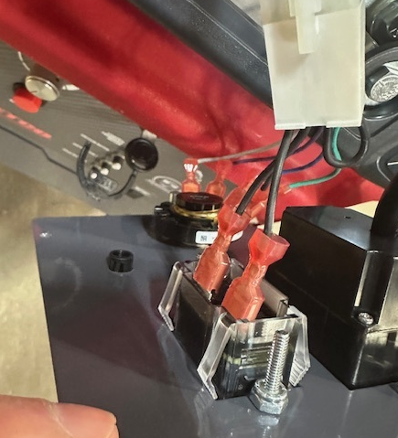

  - If the machine is equipped with SoliChem, connect the two wires from the Solichem LED to the main harness. These connectors are error proofed. The wire numbers from the harness are shown.

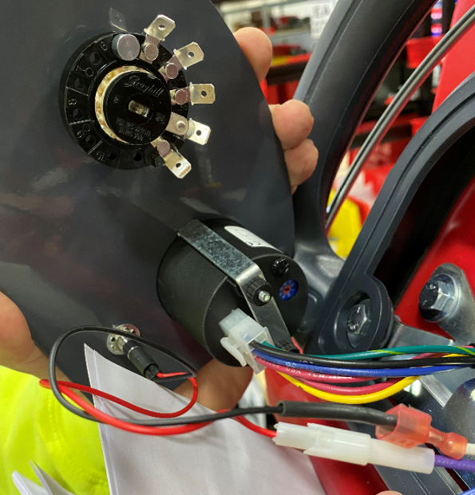
Purple-65A
White-71
  - Connect the appropriate wires from the main harness to the down pressure switch. See the photo for the wiring sequence.

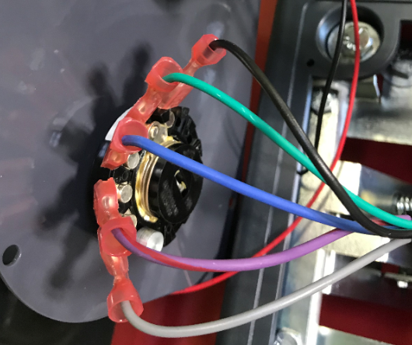
28
27
26
25
10B

  - Feed the extra wire from the battery meter down through the electrical panel and into the battery compartment.

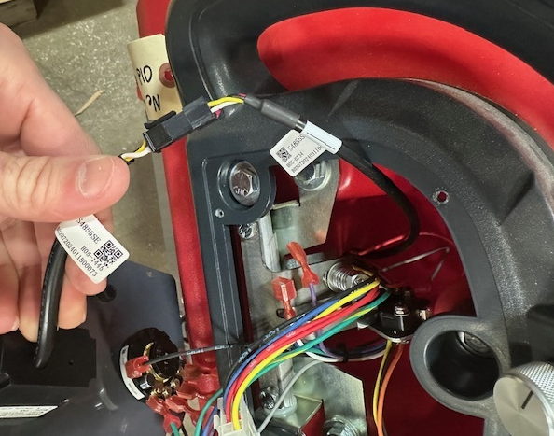
  - Mount the console panel to the handle using 4 screws (E29334). Tighten by hand and be sure not to overtighten. Pull on the knob to make sure the panel doesn’t move.

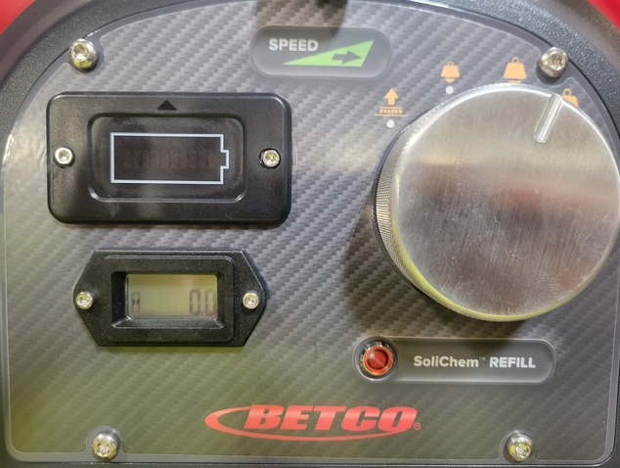

  - Get an outer electrical panel (Refer to the appropriate SOP for assembly instructions). The lithium version of the panel does not have an on-board charger on it.
  - Connect the appropriate connectors from the main harness to the circuit breakers on the panel. An orbital machine will only have 3 breakers. There are 3 pairs of 2 wires for an orbital machine. The lengths and/or how they are held by the wire ties should give the order. If not, use the wire numbers shown below. Right or left terminal does not matter.
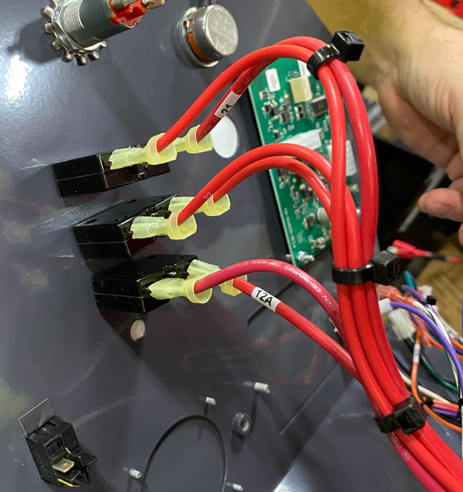
12 & 12A
32 & 32A
21 & 42
  - If the machine has SoliChem, connect the appropriate connectors from the main harness to the TDS Switch. It does not matter which switch goes to which terminal.

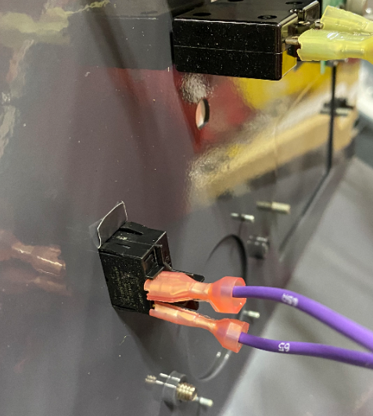
65 & 65A

  - Connect the Key Switch to the main harness. It does not matter which wire goes to which terminal.
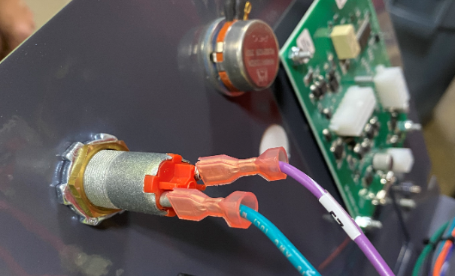
5/15/57
57

  - Connect the solution potentiometer to the appropriate connector on the main harness. It is a 2 pin connector.
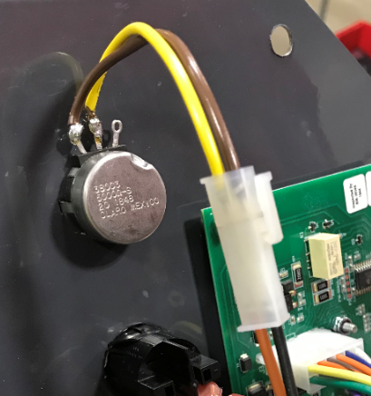
23
10R
  - Connect the appropriate connectors from the main harness to the control board. There are 3 terminal blocks to plug in (12 pin, 10 pin, and a 4 pin).

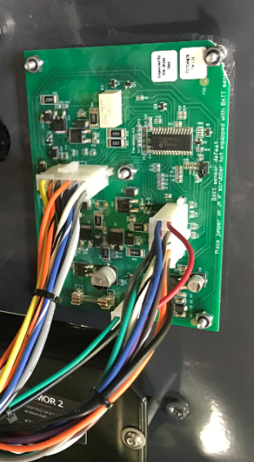
  - Locate the charger interrupt plug on the main wire harness. It is a connector with purple wires 57 and 57A. Plug a charger interlock bypass jumper (E28499) into the connector.

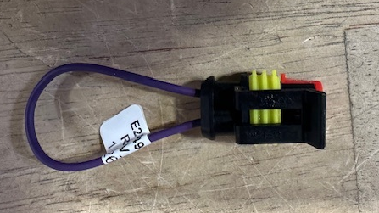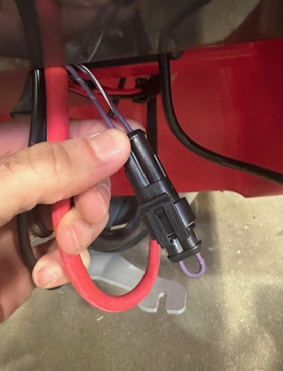

  - If the Wet Battery Protection Option is needed, refer to section 6.01 in SOP EQ 111 (Genesys MSS Final Assembly Options).
  - Mount the panel to the tank using 4 washers (E28617) and 4 screws (E28648). Be careful as they can strip. Make sure all wires are tucked inside on the cavity and don’t get pinched. The main portion of the harness should pass through the cutout in the panel.

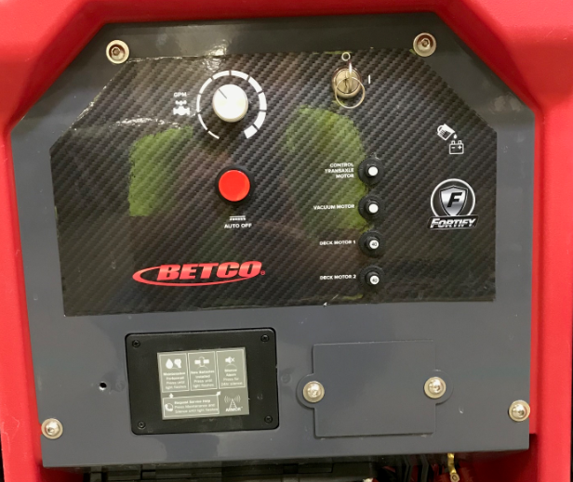
Main Harness should pass through here

  - Since this is a lithium unit and doesn’t have an on-board charger, you can remove the cord wrap on the side of the solution tank. The wrap and the screws can go back into stock.

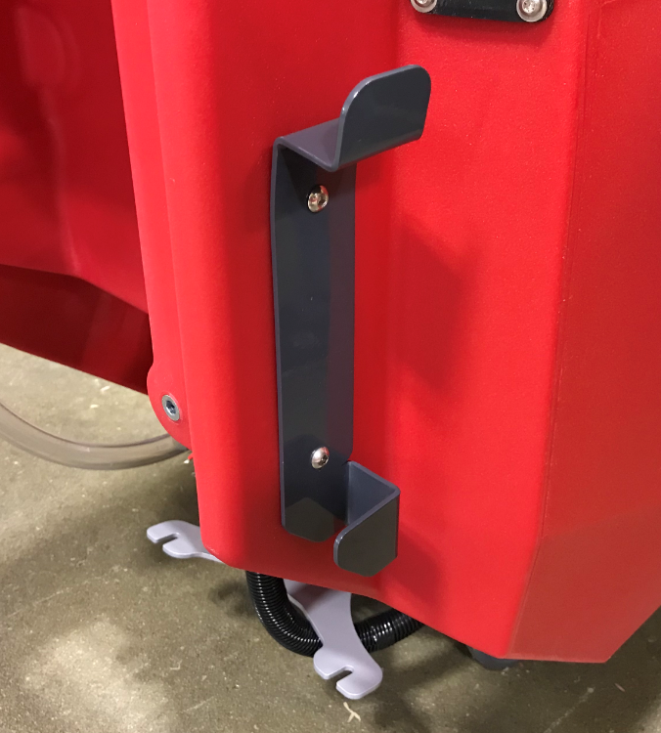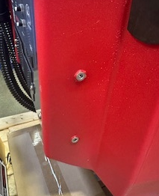

  - Mount the appropriate sized squeegee assembly to the machine. See the required SOP for assembly instructions. (35” squeegee for a 26” machine / 40” squeegee for a 28” machine / 45” squeegee for a 32” machine). Mounting the squeegee will also help keep it from rolling.

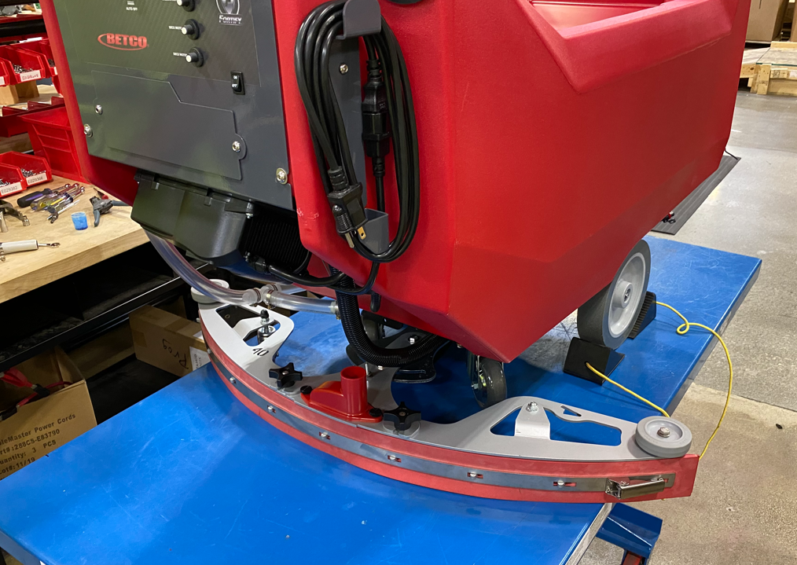

  - Ensure the key is in the “OFF” position. Connect the other end of the battery cable assembly (E28497) to the + and – terminals of the battery.

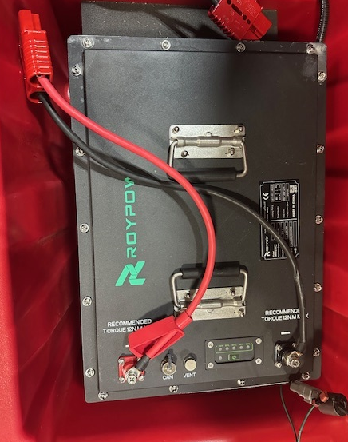

  - Connect the cable that comes from the battery indicator to the CAN port on the battery.

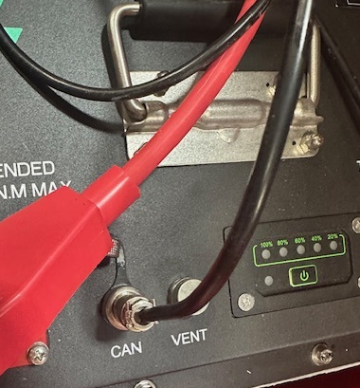

  - Attach the orbital track mounting bracket (E28680) to the solution tank using 4 bolts (E81089) and 4 washers (E28622). Use blue Loctite on the threads. Ensure the arrow points up. Push the bracket all the way up in the slots before tightening.

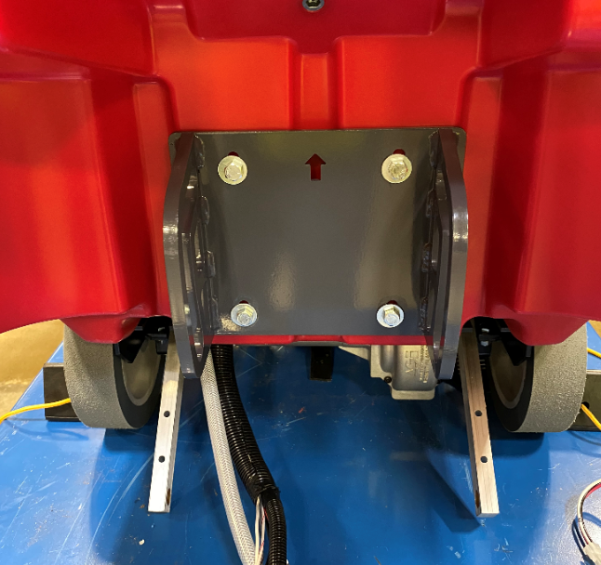

  - Install a lift arm brace (E28678) using 4 hex bolts (E28702), 8 flat washers (E28617), and 4 nylock nuts (E28853). Ensure that the flange on the bracket is pointing up.
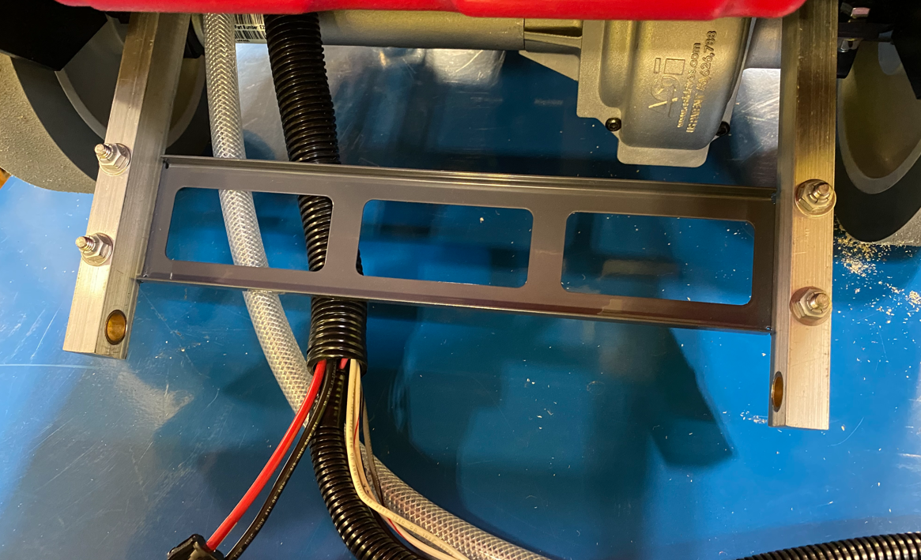
Flange
  - Position the head assembly up to the machine frame/body. Refer to the appropriate SOP for how to build the orbital head if needed. Line the roller brackets on the head up to the slot on the roller track bracket. Ensure that the harness/hose passes under the lift arm brace and then over the head.

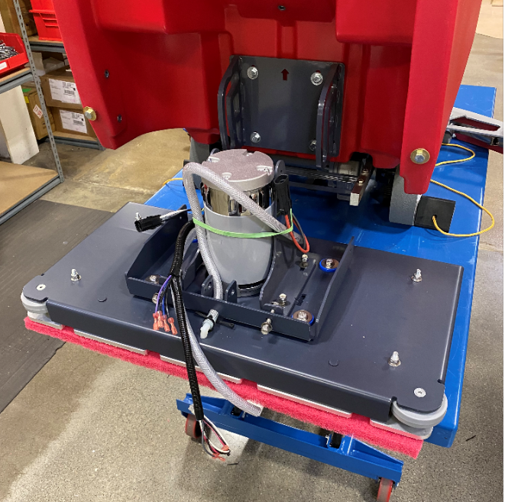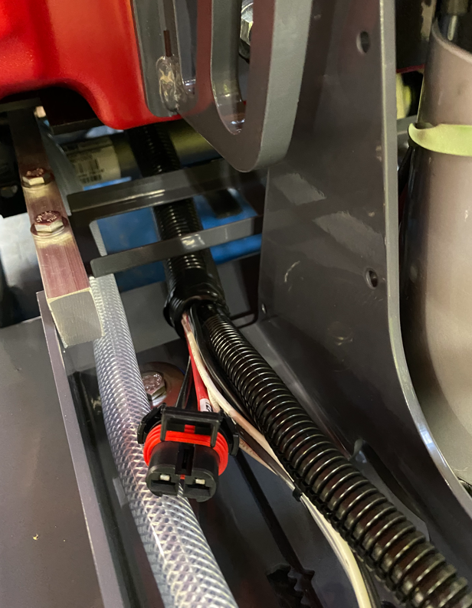

  - Attach the head to the frame at the lift arms. First, install a sleeve bushing (E28693) into the end of each lift arm bearing. Then attach using a hex bolt (E28694), 2 flat washers (E28622), and a nylock nut (E81063) on each. Use 2 plastic washers (E83145) as spacers to remove any side to side slop at the connection point. Put them on the inside and the outside of the arm as long as they fit. If there is no slop, don’t use them.

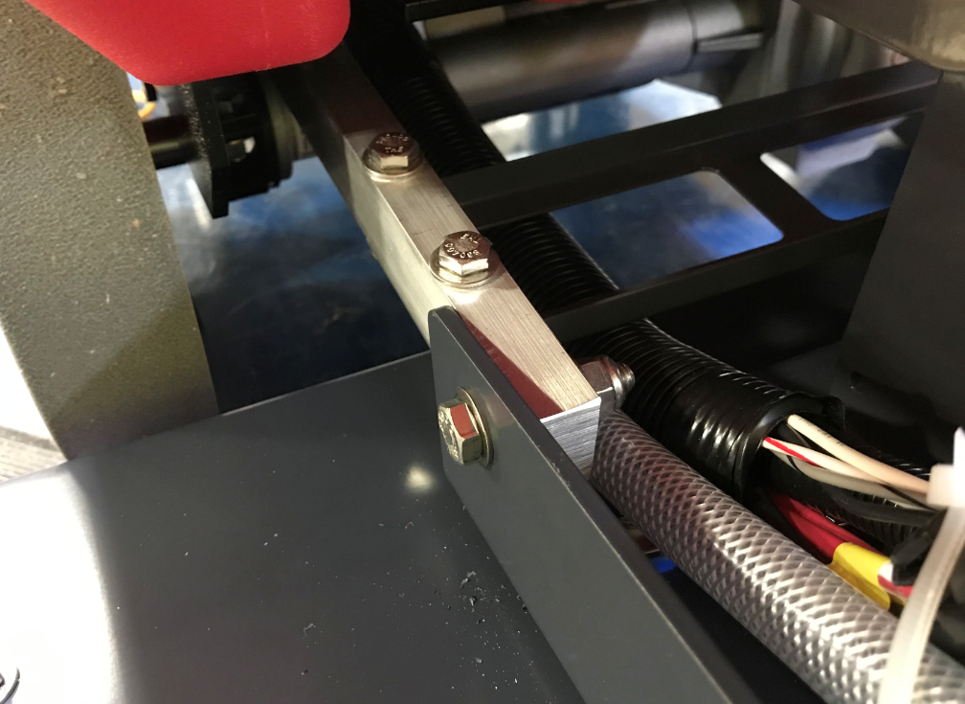
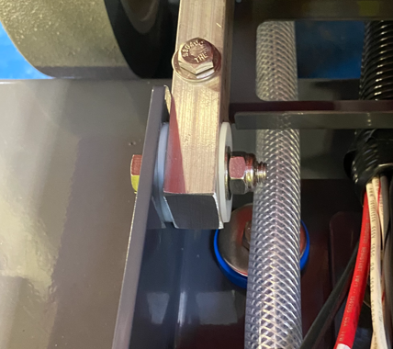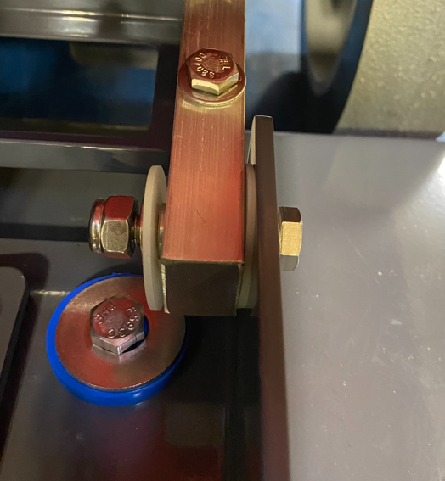

  - Take a roller bushing (E28835) and put it into a roller (E28836). Make 2 of these. Put this roller into the slots in the track mounting bracket and attach them to the head brackets. Use a hex bolt (E84556), 2 flat washers (E28622), and a nylock nut (E81063) to attach each one.

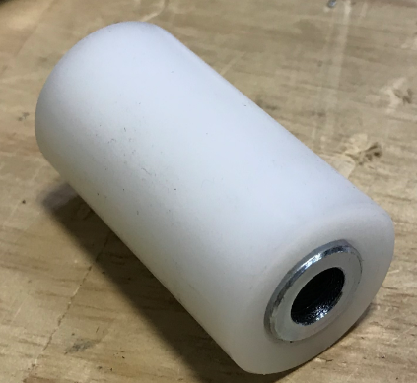
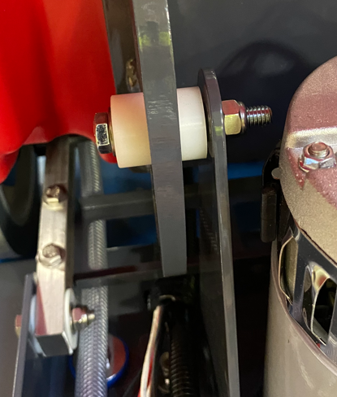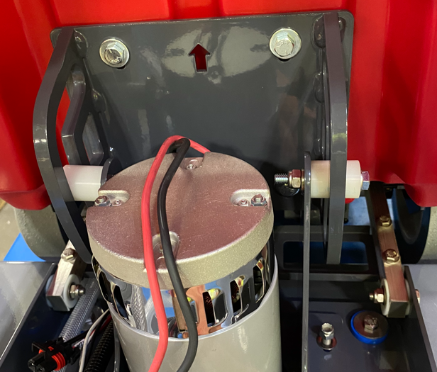
  - Tighten the 4 screws that hold the roller brackets to the deck about 90% of the way. They should not be tight but should not allow the brackets to move excessively.

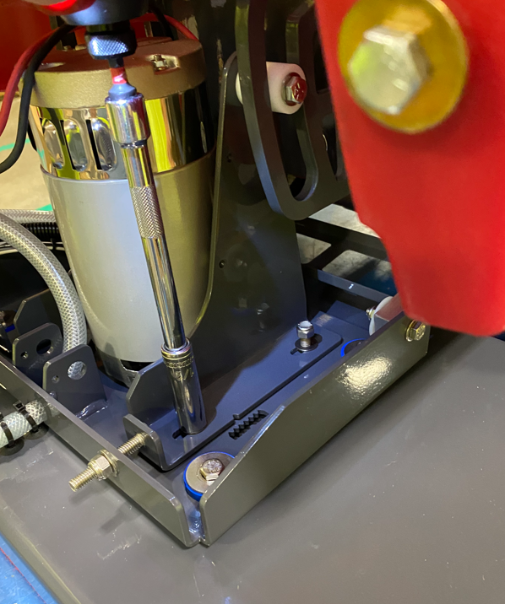
  - Connect the motor connector to the proper terminal on the main wire harness.

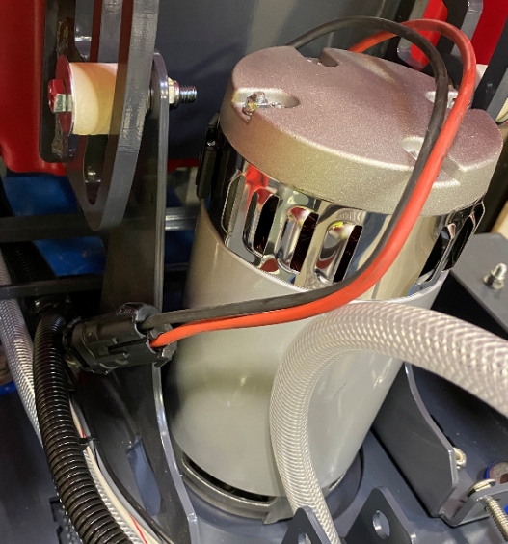

  - Use a zip tie (E88890) to bundle the wires and hoses from the machine as shown.

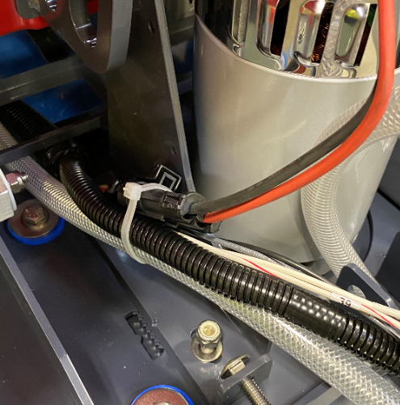

  - Get a head lift assembly equipped and a head lift support bracket (E20702). (Refer to the appropriate SOP for head lift assembly instructions) Insert the support bracket into the bracket as shown. The slotted holes in the bracket will align with the ones on the head lift.

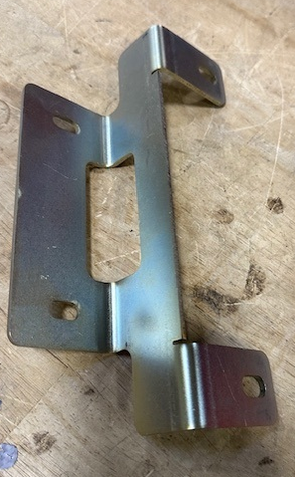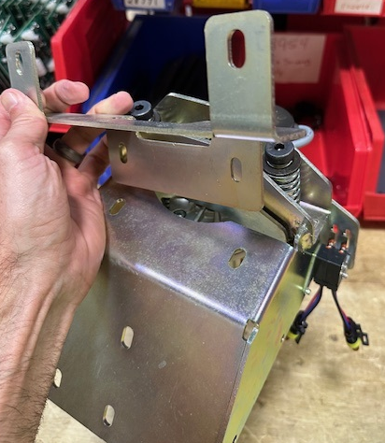
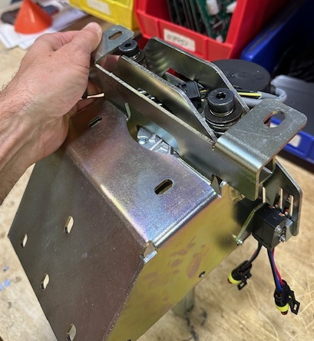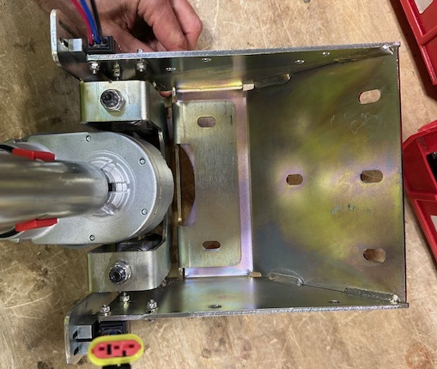

  - Attach the head lift to the solution tank using 4 bolts (E81089) and 4 washers (E28622). Use blue Loctite on the bolts. Tighten them all evenly so that the assembly locates properly against the tank.

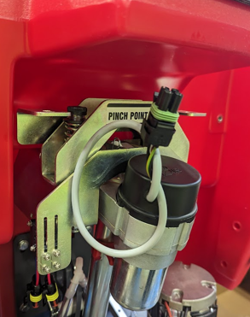
*Note: Slide head lift support bracket as flush to the tank as possible to minimize the gap between the bracket and tank.

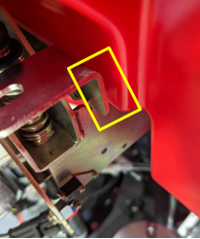

  - Add a red support strap (E20703) above the front fill port. Attach the support strap using 2 bolts (E10112), 4 washers (E081062) and 2 nuts (E28623) using a ½” wrench.

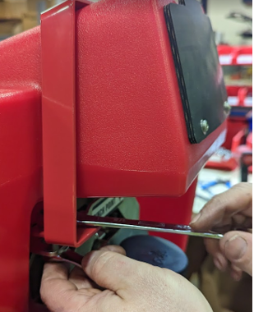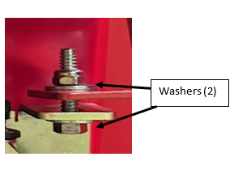

*Note: Tighten the bolts so they are snug, but not too tight. Do not draw the bracket and strap plates together.
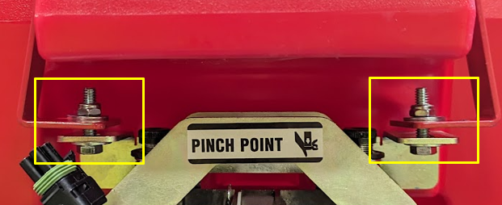

  - Connect the cable for the actuator to the cable on the power supply. Turn the power supply on.

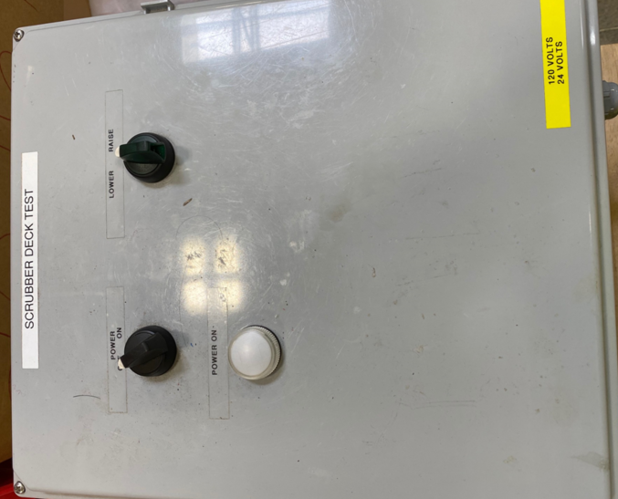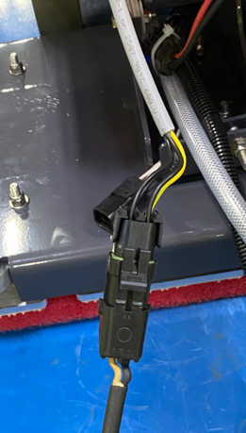

  - Remove the red clip from the actuator. Do not spin the actuator sleeve by hand. Hold the actuator sleeve stationary (so it doesn’t rotate) and turn the knob on the power supply to the “Lower” position. This will lower the end of the arm to the deck. Fine adjust it when it gets close so that the hole in the actuator shaft lines up with the hole in the bracket.

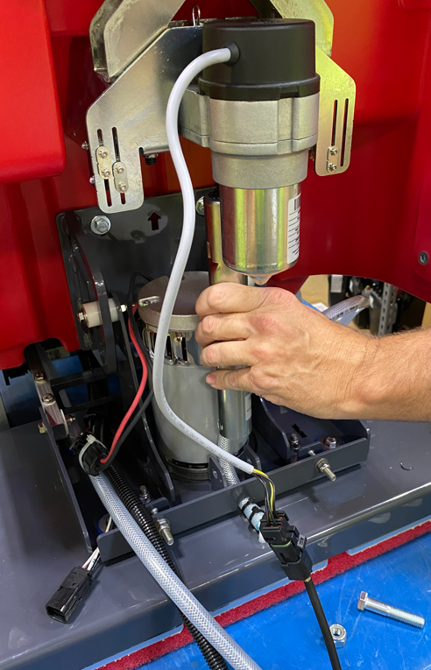

  - Secure the actuator arm to the deck using a bolt (E28815) and a nut (E12410). If there is a gap, place a plastic washer (E83145) between the actuator arm and the head lift bracket to eliminate any slop.

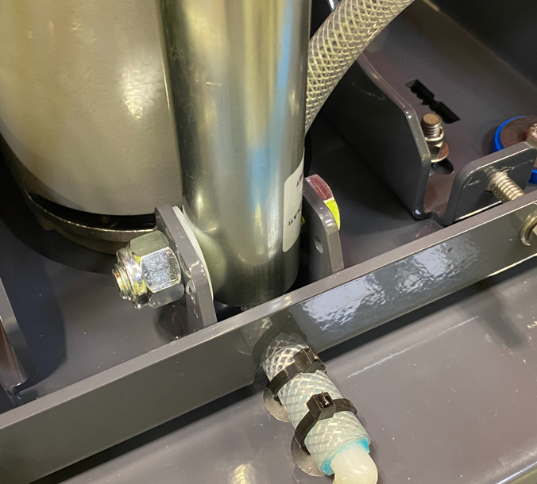
  - Manually raise the deck until it stops. Cycle it back down until it lands flat on the table.

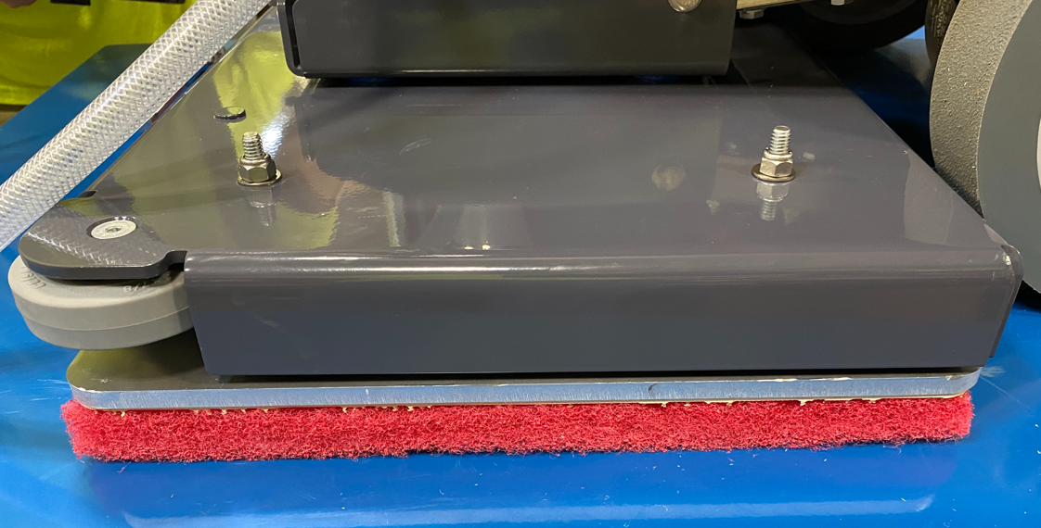

  - Tighten the carriage bolts to draw the rollers into the outer side of the weldment slots. This will reduce vibration. Go back to the nuts holding the roller brackets and tighten them all the way. Give the 2 nuts on the carriage bolts one final snug to ensure everything is tight.

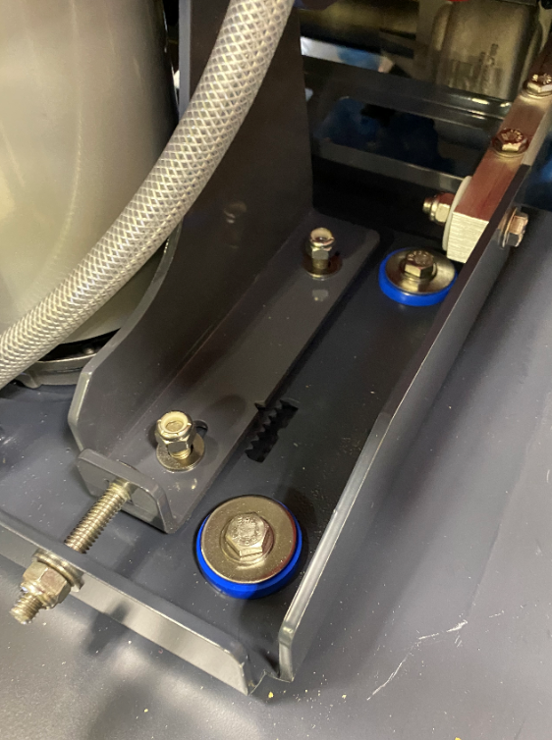
Orbital Unit Shown

  - Cycle the head up and down again and ensure that the head still lands flat. Adjust the bracket again if necessary.
  - Disconnect the actuator from the power supply.
  - If the machine is equipped with a Solichem system, get an assembled solution canister and a puck cage. Place the puck cage into the canister. Refer to the appropriate SOP for assembly instructions.
  - Attach the tube to the machine using 2 loop clamps (E28969), 2 screws (E28648), and 2 washers (E28617). Line it up so that the top cap is just above the upper clamp. This will ensure that the lid does not interfere when it is closed.

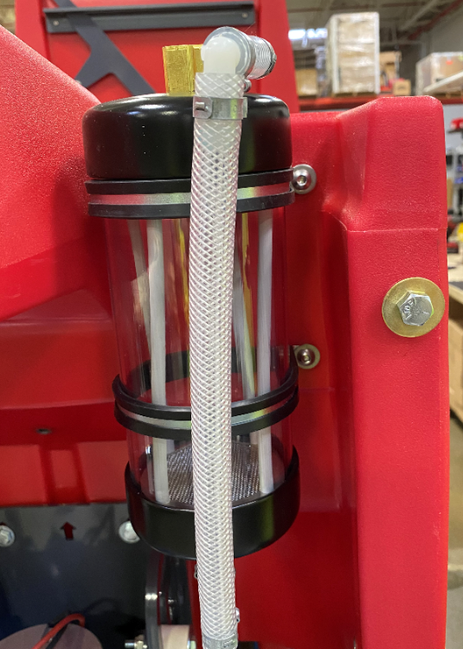

  - Connect the supply line coming from the pump to the inlet port on the solution canister. Place a pinch clamp (E28773) onto the hose. Ensure the slope of the hose relatively matches the photo. Trim if needed. Once it is positioned properly, pinch the clamp to secure.

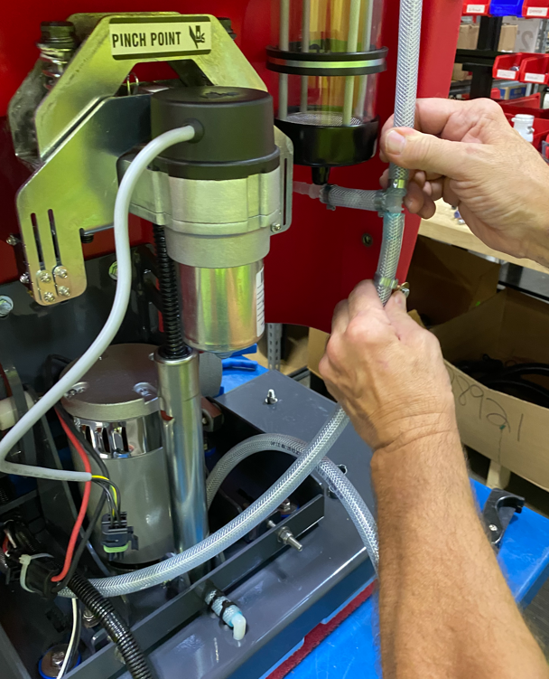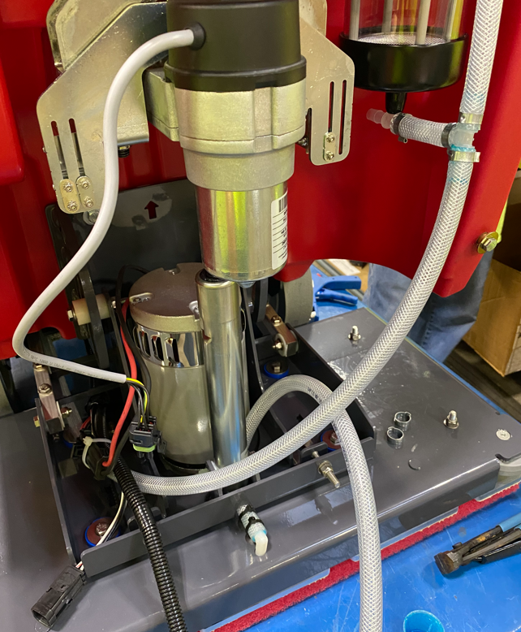
  - Connect the solution line from the spray bar on the deck to the outlet port of the solution canister. Ensure that the slope and orientation match the photo. Trim if needed.

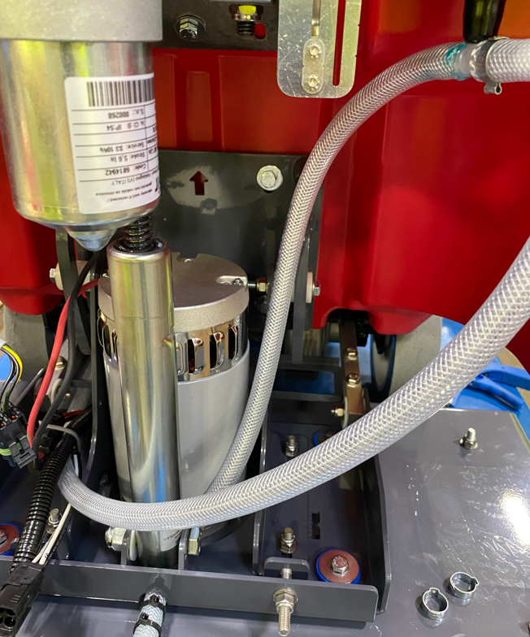

  - Get a TDS Board assembly and 2 conductivity probes. Refer to the proper SOP for how to build these.

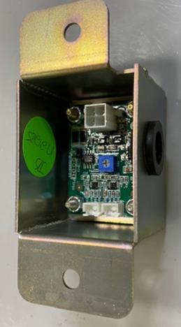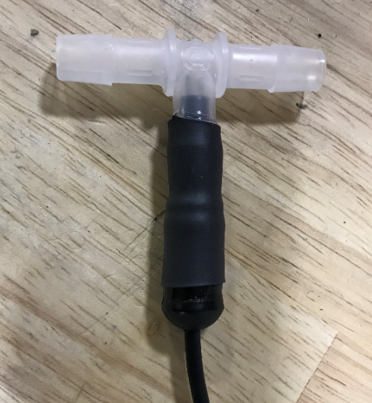

  - Install a probe into the feed line going to the deck. Cut the hose about 6” from the canister to install. This will ensure the probe is close to horizontal portion of the hose yet away from the motor when the deck is raised. Orient the probe to be as vertical as possible.

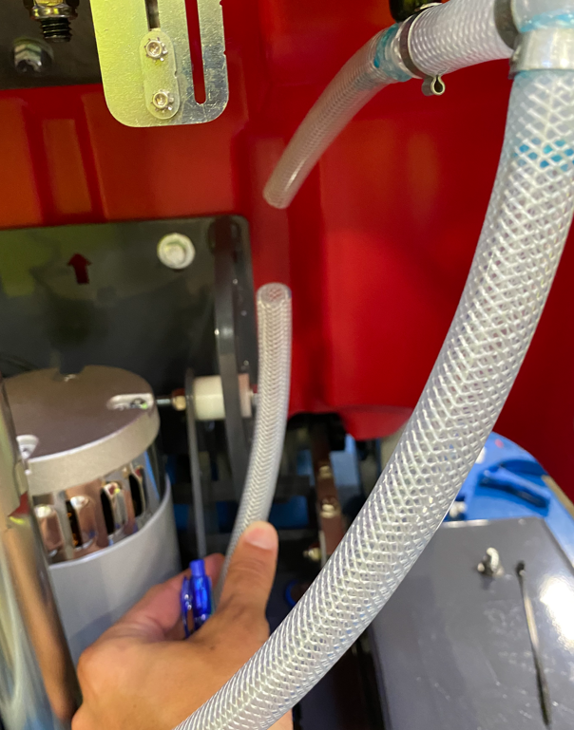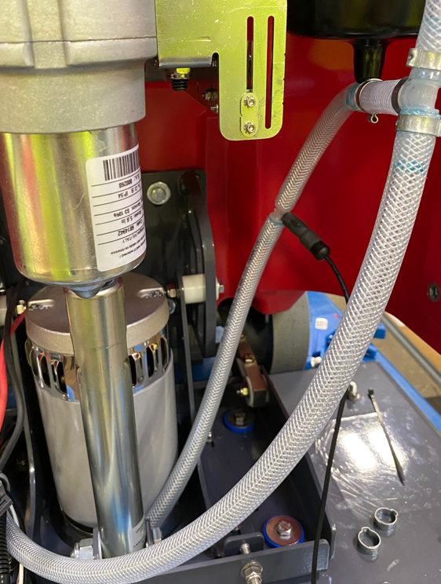

  - Install the probe into the supply line from the pump. The probe needs to be pointing upwards as best as possible. Cut into the supply line close to the deck where the hose starts to flatten out. This will be about 8”-9” from the canister. Install the ends of the T into each hose with a pinch clamp (E28773) over them. Orient the probe to be as vertical as possible. Also make sure that it will not hit anything as the deck moves up and down. Pinch the clamps once it is oriented properly.
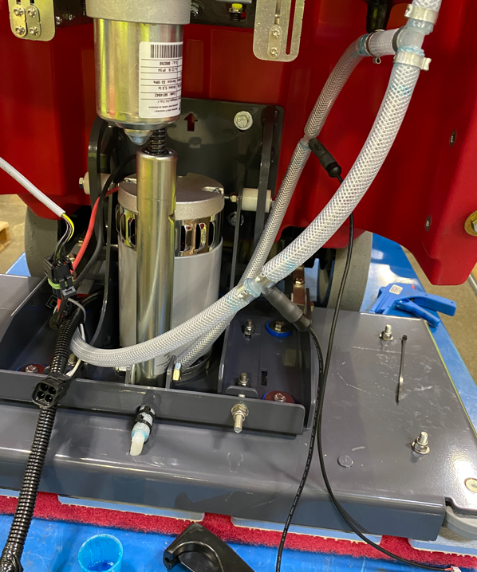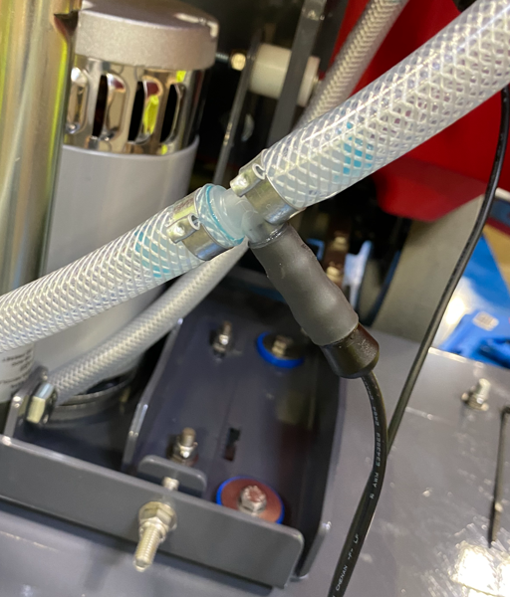
  - Pop the rubber grommet out of the TDS box and pass the 4 pin terminal from the main wire harness through it and into the box. Connect it to the proper terminal on the board. Ensure that the jumper on the board has been removed.

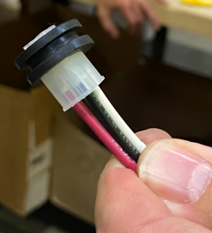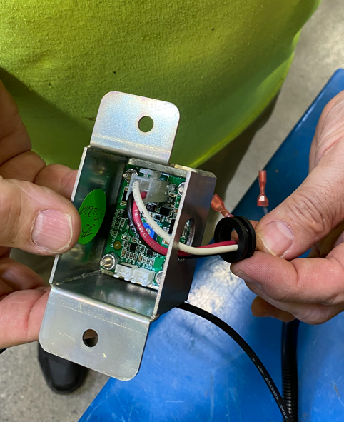

  - Take the wire from the probe on the feed line to the deck and pass it over the pump supply line as shown.

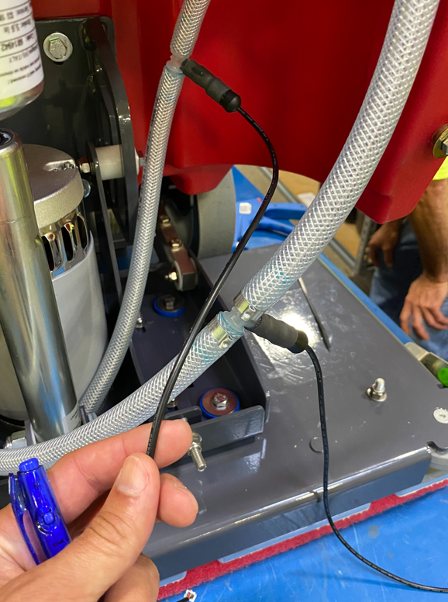

  - Feed the ends of the probe wires through the hole in the bottom of the TDS Board box. Connect the probes to the proper terminals. Ensure that the probe terminal with the black line is connected to the board terminal with the black line. Put the grommet back into the hole.
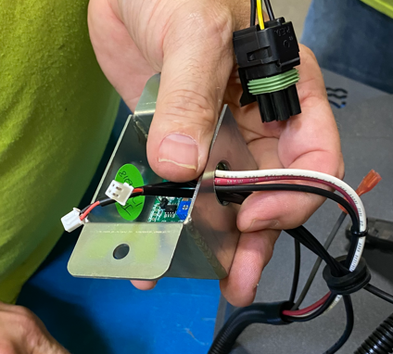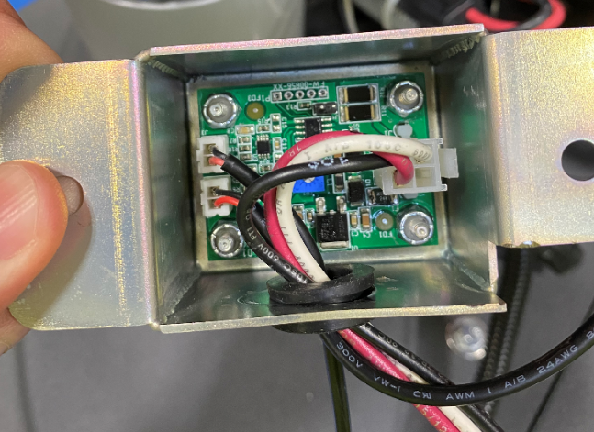
  - Cut about 12” of 3/8” loom (E11213) and wrap it around the bare wires at the ends of the harness going into the shield bracket. Feed the end of the loom through the grommet.
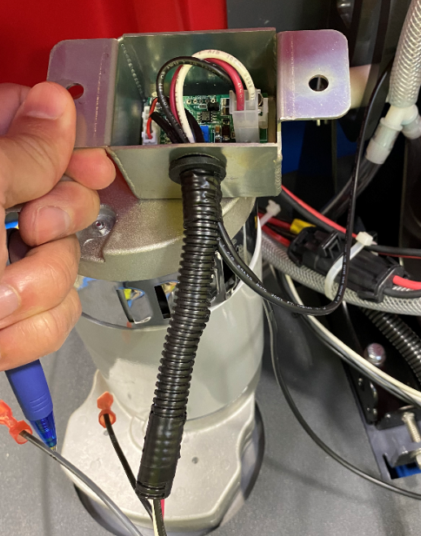

  - Mount the TDS Board to the inside of the head lift on the right side using 2 bolts (E29410) and 2 nuts (E28853).
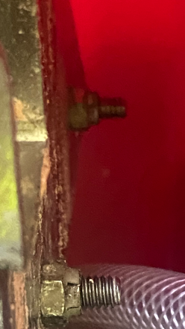
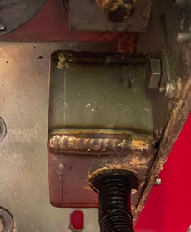

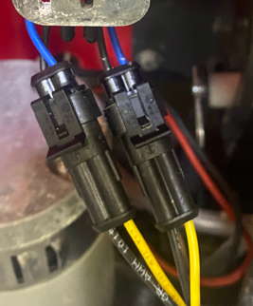
  - Connect the Low and Medium Pressure Switches to the appropriate terminals on the main wiring harness. (Assembler Left Side)
Medium Pressure – Purple wire from Harness
Low Pressure – Blue wire from Harness

  - Connect the High-Pressure Switches to the appropriate terminals on the main harness. (Assembler Right Side)
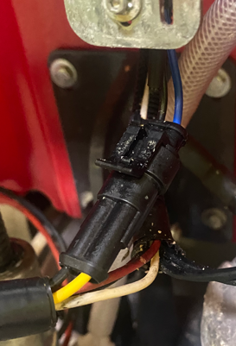
Gray Wire from Harness

  - Be sure the harness passes in front of the actuator as shown.

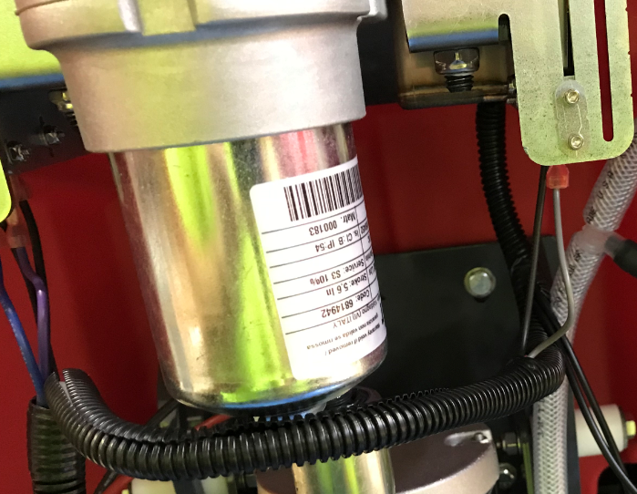

  - Wrap the actuator wire around the harness to take up the slack and keep it from moving around. Connect it to the proper terminal on the main harness.

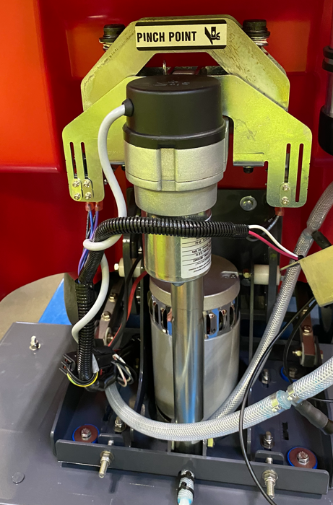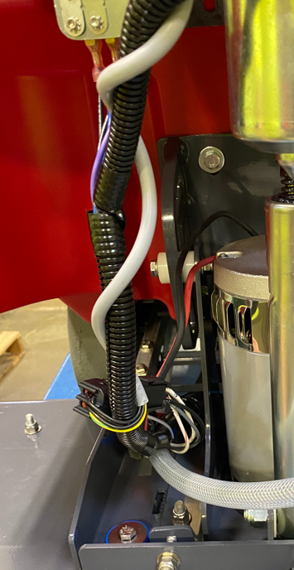

  - Plug in the SB175 Anderson connector in the battery compartment. Turn on the battery by pressing and holding the power button for 3-5 seconds. Turn the key on and the deck should raise up. Ensure all of the cables and hoses are still resting properly.

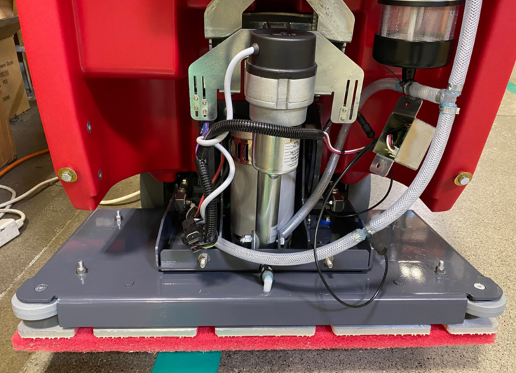
  - Refer to the appropriate SOP for instructions on how to assemble a Recovery Tank.
  - Place the tank near the machine using the cart shown. This will angle it to allow it to be attached easier. Bring the tank over to the machine and adjust the build cart height to allow the first hinge to be attached.

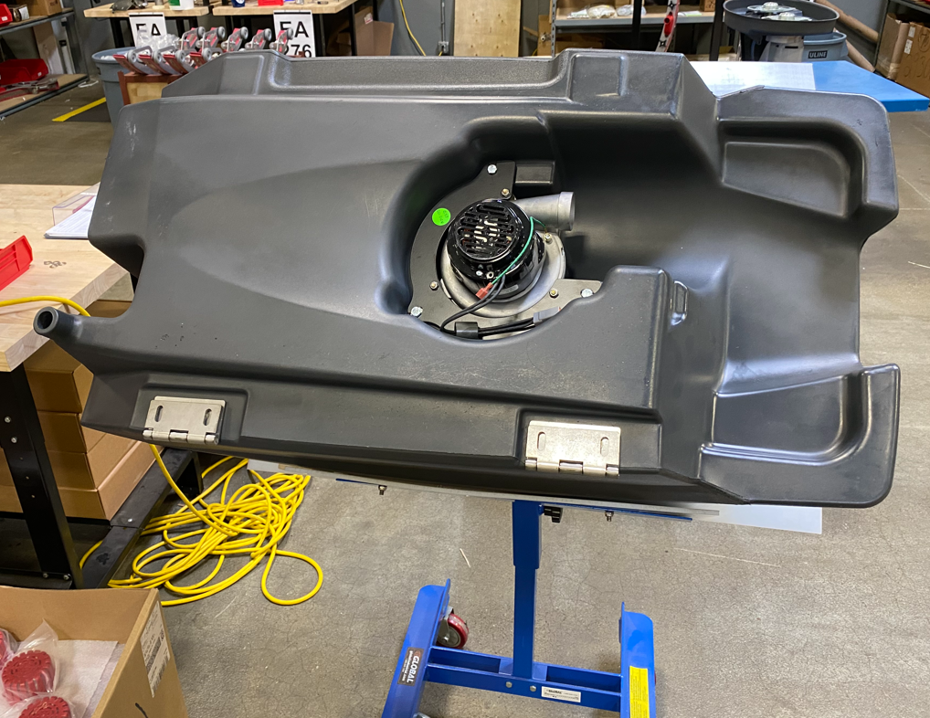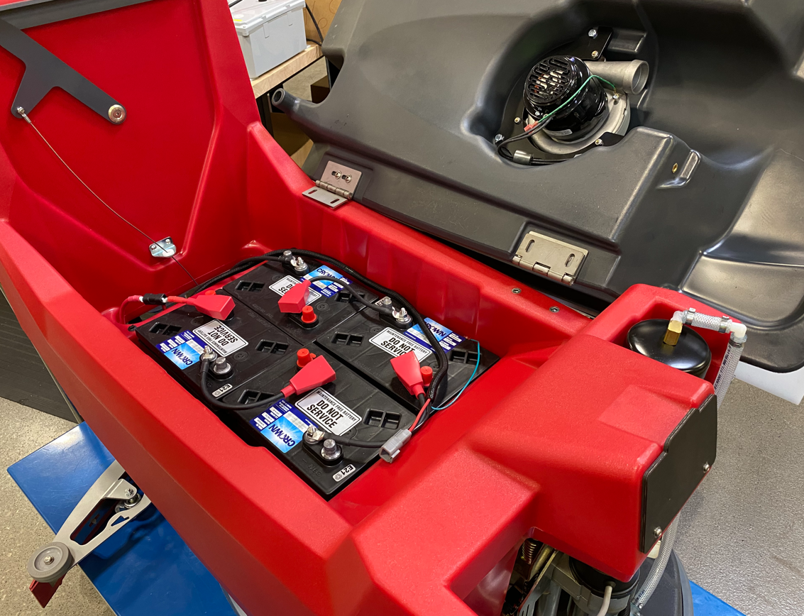

  - Attach the first hinge using 2 flange bolts (E29569). Once that is done, adjust the build cart height to allow the 2nd hinge to be attached. Use 2 more flange bolts (E29569) to attach.
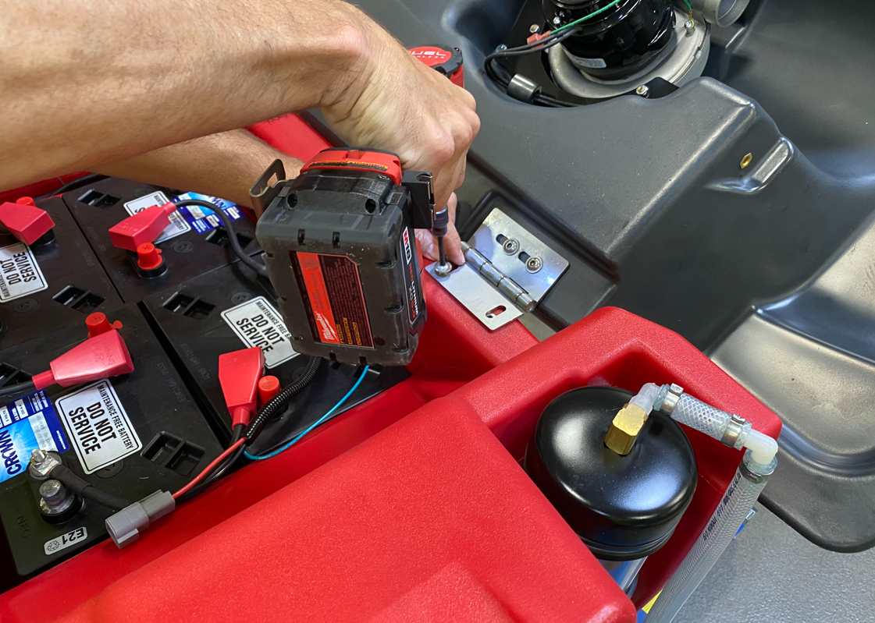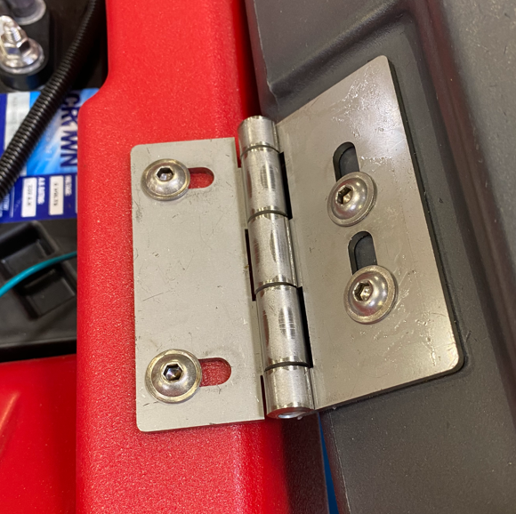

  - Close the recovery tank lid and verify that it is centered on the machine. If not, open it back up and readjust by loosening the screws and move it. Continue until it is centered. **There is nothing keeping the recovery tank from falling all the way open. Ensure either the cart is in place or there is another person helping hold it open if adjustment is needed.**
  - Attach the solution and recovery tanks using a recovery tank cable (E28760). Attach each end of the cable using a hex bolt (E29392) and a hex nut (E12524). Thread the bolt in part way, then tighten the nut to the tank to ensure the cable end can pivot. **Note-Ensure that the cable loops down into the solution tank cavity as the lid is closed. If it loops upward it could loop around the HEPA filter and tear if off. If it loops up, either put a kink in the cable or turn one of the ends of the cable 180°.
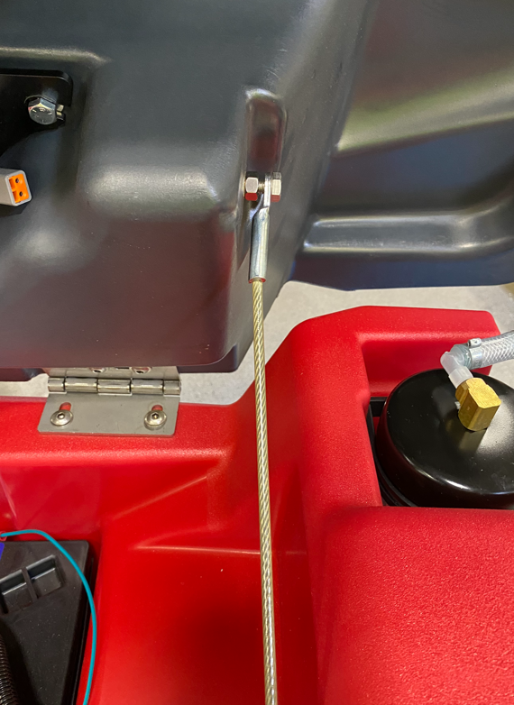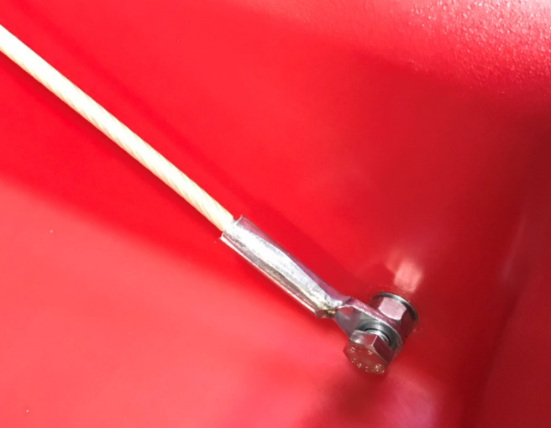
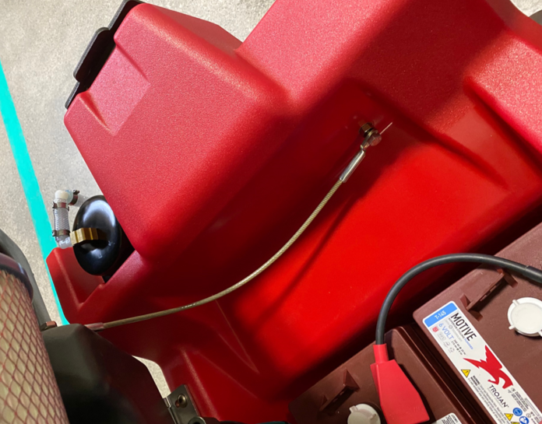
  - Install a HEPA filter (E29527) onto the vac motor using a worm clamp (E28755). Use the provided torque screwdriver to tighten the clamp to 15 in-lbs of torque.

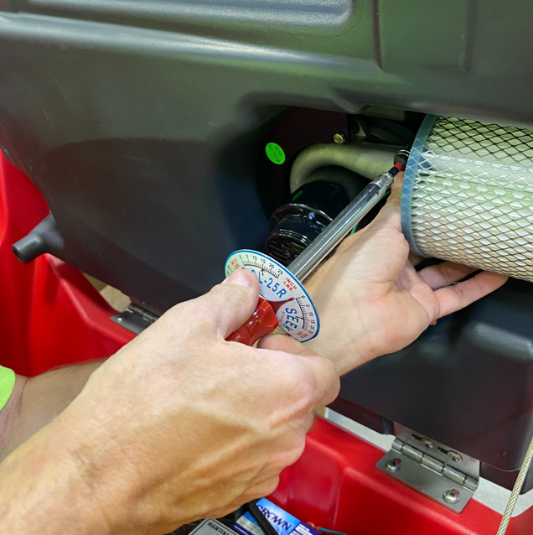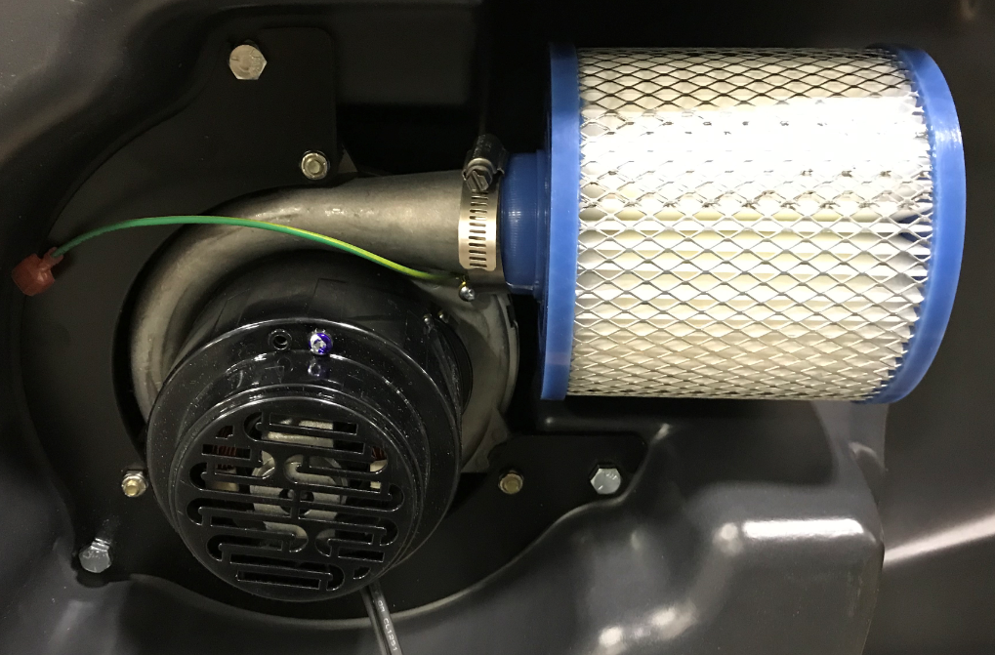

  - Connect the vac motor and the ground wires to the main wire harness. Clean up the wiring in the tank using 2 zip ties (E83523).

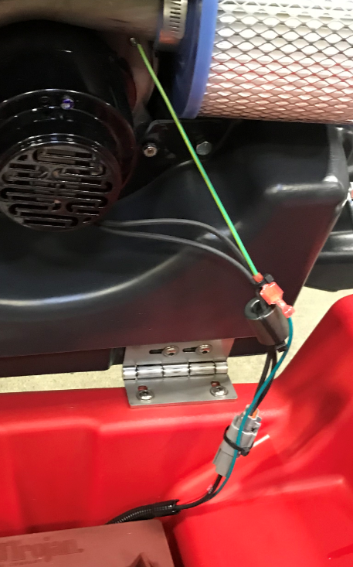

  - Clean up the wiring in the battery compartment. This step uses 3 zip ties (E83523).

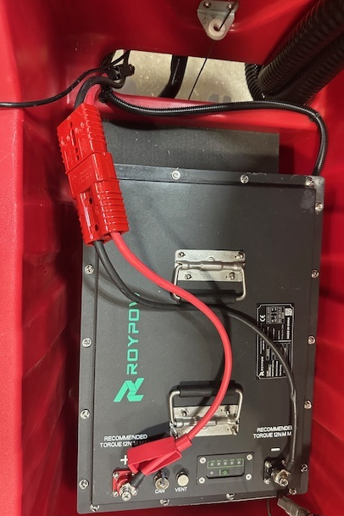

  - Take a squeegee vac hose (E29576) and press the angled end onto the barbed fitting on the back of the recovery tank.
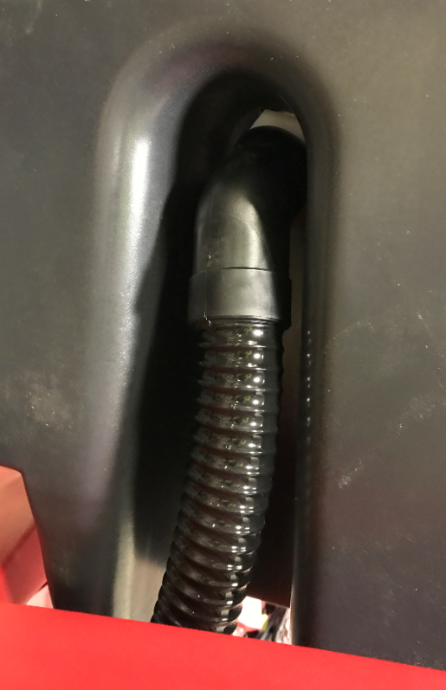
  - Take a recovery tank drain hose (E28921) and attach it into the drain port of the recovery tank by using a worm clamp (E83966).
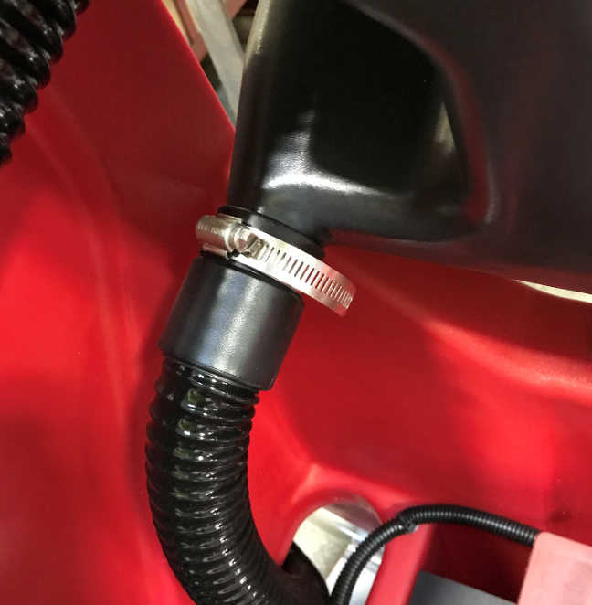
  - Route the 2 hoses out of the battery compartment.

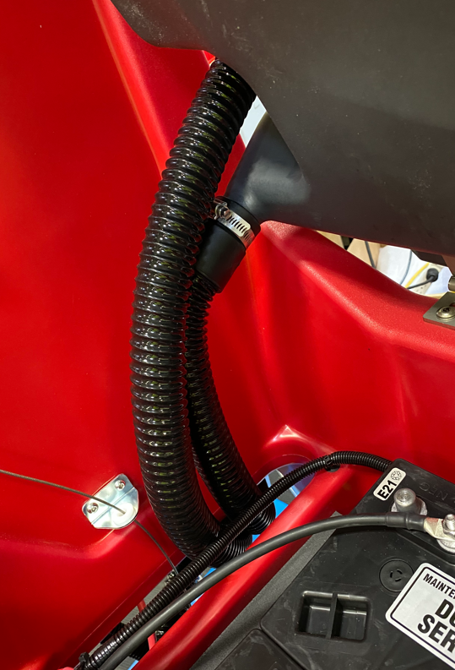

  - Connect the end of the squeegee vac hose to the port on the squeegee. Hang the end of the recovery tank drain hose as shown.

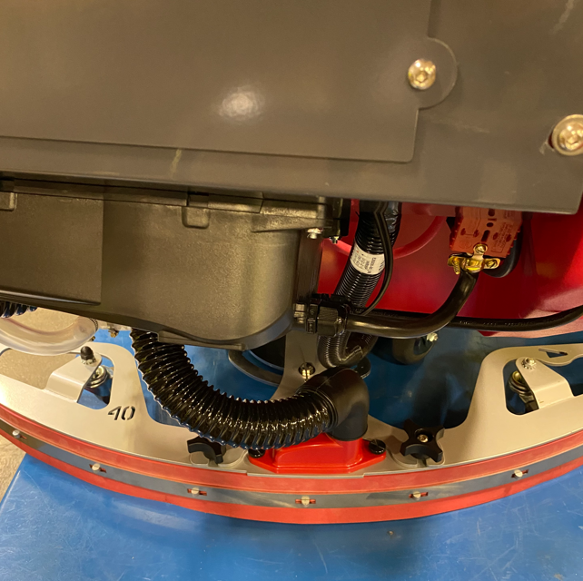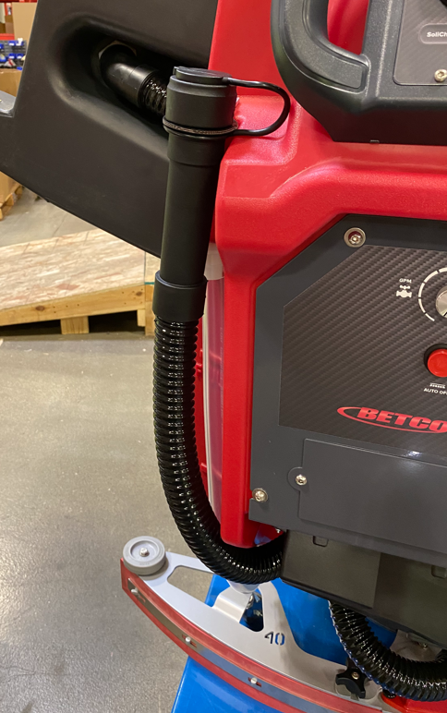

  - Take a recovery tank lid (E28577). Put a little blue silicone gasket maker into the groove in a couple points to hold the gasket in place. Be sure to put some under each end of the gasket. Cut a 7’ length of gasket (E29528) and install it into the groove. The edge with the rounded bulb goes towards the outside of the lid. Trim as needed to get the ends to line up.
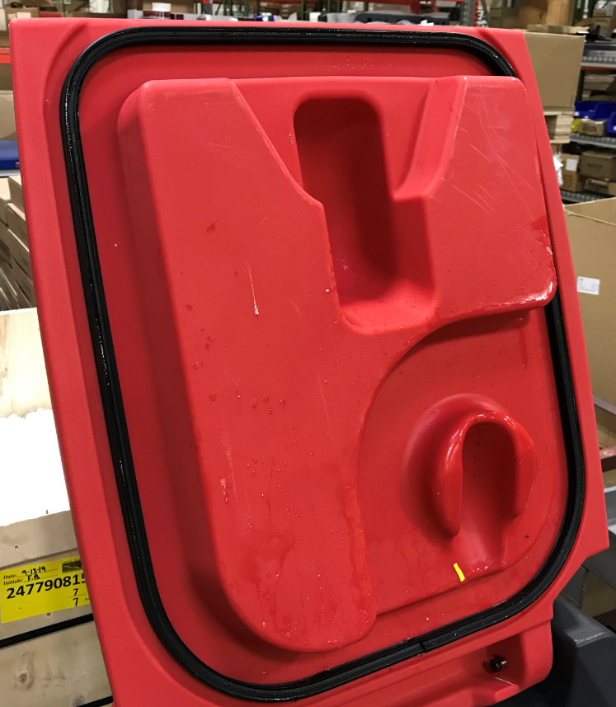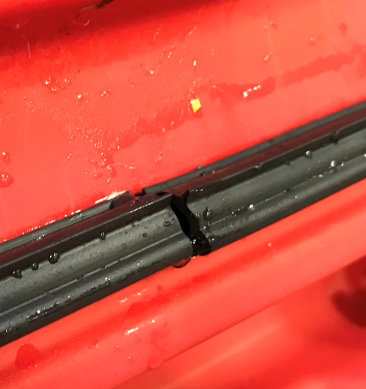
Ends meet here
  - Attach the lid to the tank using 2 shoulder bolts (E29558).

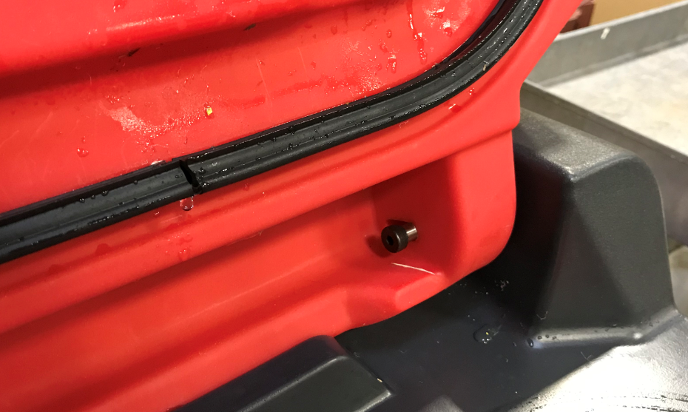

  - Attach a debris tray (E29525) to a puck holder (E29561) and place them into the pocket in the tank.

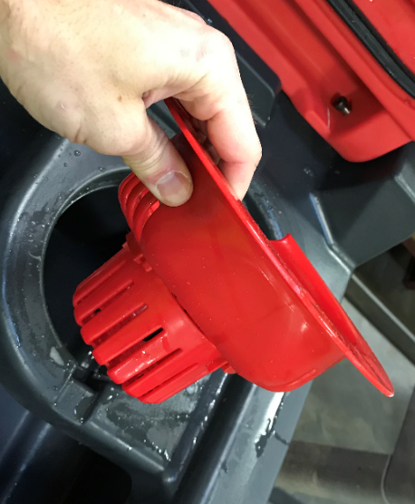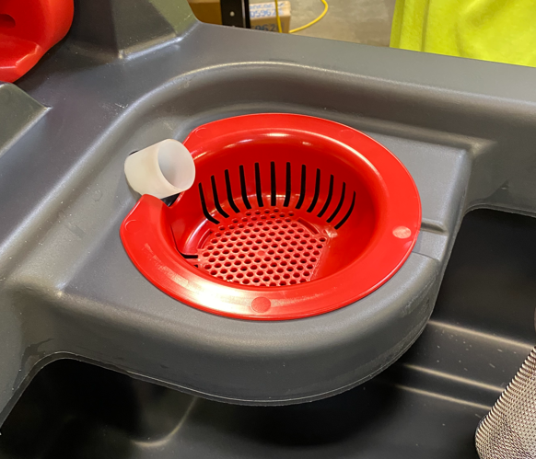

  - Close the recovery tank lid.
  - Do a quick functional check of the unit to make sure all of the functions work prior to sending the machine to QC.
    - Verify vac motor turns on and off as required.
    - Verify head lift goes up and down. The head lift switches are not yet set but moving the knob to down pressure 1 should start it moving down. Once you verify it moves down, turn the knob back to the UP position and it will retract.
    - Ensure the wheels are chocked and quickly check the transaxle. Turn the speed knob all the way down and pull the bail. You should feel the machine try to move.

- References (optional section as needed)

- Training Guide

Functional Training Groups Requiring Training
Equipment Assembly Group

- SOP Change Control

Date of Change | Reason for Change
Rev 01 – 1/30/2026 | This is the first version of the S.O.P. hence there are no revisions to this document.

Approvals

Submitter/Author Approval:__________________________________ Date:______________________

Management Approval:______________________________________ Date:______________________

QAU Approval:_____________________________________________ Date:______________________

